BATTERIES

Asmaa Pandit

NERD GIRLS

Fall 03-Spring04

TABLE OF CONTENTS
Page

- Battery Preferences 3

- Description of Batteries 5

- Battery Curves 7

- Battery Comparison 12

- Battery decision (early spring) 13

- Final conclusion on Batteries 16
- Battery Spreadsheet (see attachment)

BATTERIES COMPARISON

TABLE 1

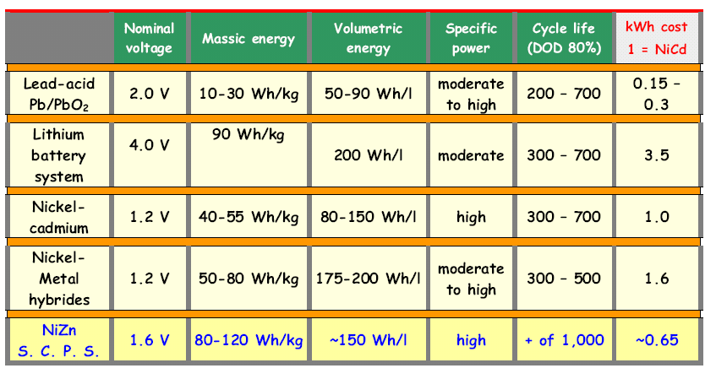

TABLE 2. Comparison of the batteries with detailed comments

Type | Energy  Density  (Wh/Kg) | Energy  Density  (Wh/L) | Power  Density  (W/kg) | Price  ($/kWh) | Cycle Life | Internal  Resistance  (mOhms)[1] | Temp  (deg. C) | Comments
NiMH  (similar to NiZn) | 75-120 | 150-240 | >250 | 250 | 600-1000 | 15-50 | -30 --60 | ~Exceeds all performance criteria ~No memory effects ~Infinite storage capability  ~Availability issues  ~High initial cost
NiCd | 60 | 110 | 200 | 350-600 | 500-1000 | 0 | -40—60 | ~Too toxic, memory problems (because of sharp drop-off point on discharge curve)—BAD!  ~Zero internal resistance = meltdown  ~Availability issues  ~High Cost
Li ion | 110~150 | -- | -- | Around 300/400 | 300-700 | -- | -20 ~ 75°C | ~Good charge and discharge curves—flat (produces stable power)  ~Light compared to others  ~ High cost
Lead Acid | 30 | -- | -- | ~70 | 200-2000 | -- |  | ~Good charge and discharge curves  ~Heavy  ~Reliable  ~Low cost

Asmaa Pandit
Fall 2003

DESCRIPTION OF BATTERIES

- Silver chloride: too expensive, have to be recharged often
- Lithium MH
- Lead Acid: conventional but too heavy
- Lead Selenium.

PowerGenix Ni-Zn battery not only has the highest energy density at lower discharge rates but also that the margin actually improves as the discharge rate is increased. The effect of this high pulse current has been to significantly shorten the life of conventional Ni-Cd batteries. Based on current data no such effect has been seen with the PowerGenix Ni-Zn battery.

Lithium-ion batteries, compared with other typical lead and nickel hydride batteries, have superior energy density (energy that can be extracted per unit mass or per unit volume), power density (power that can be extracted per unit mass or per unit volume), and are currently the most desirable second-generation battery.

Lead-acid is the most conventional one. Its main advantages are cheap and highly recyclable, but it is poor in energy efficiency (i.e., generates less power per kg of weight) and takes a full night to recharge.

*** *** ** *** ** **

Another battery is Nickel-Metal Hydride (NiMH), currently being used by Honda EV Plus and many others. It is one times more efficient than Lead-acid, that means it can double the range of the car or reduce the battery weight by half while maintaining mileage. Besides, it takes shorter time to recharge, and last longer. Any disadvantages? Yes, very high price.

The latest newcomer is Lithium-ion battery, which was developed by Sony and has been installed in Nissan Altra EV. It is even more efficient than Ni-MH, even more durable and even quicker to recharge. Disadvantage is still even high price and difficulty to be recycled. The lithium ion batteries are rapidly into laptop and cell phone markets because of their high specific energy. They also have high specific power, high-energy efficiency, good high temperature performance, and low self-discharge. Components of lithium ion batteries could also be recycled. The cycle life is also pretty good as for our design. And it is light in weight! However very expensive…

Electric vehicles with lead acid batteries have limited range, allowing drivers to travel only relatively short distances before they must recharge. Lead-acid batteries with a specific energy (energy-to-weight ratio) of 30-40 watt-hours per kilogram (Wh/kg), at a cost of up to $150 per kilowatt hour, are not adequate for competitive electric vehicles.The targets for advanced battery performance are a specific energy of 150 Wh/kg at a cost of $150 per kilowatt hour. Other goals include power-to-weight ratios of 300 watts per kilogram and a ten-year useful life.

The nickel Metal hydride battery is currently the technology that has come closest to achieving these objectives, and although U.S. and major Japanese automakers are now offering this battery in their electric vehicles, this technology still falls short of the USABC’s performance and cost targets.

Lithium-based batteries appear to offer the best chance for meeting those targets.

Fall 2003

BATTERY CHARGE AND DISCHARGE CURVES

Nickel Metal-Hydride

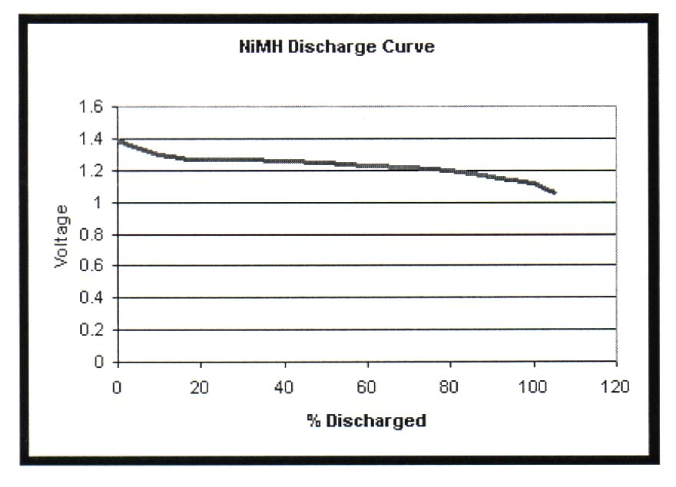

Nickel-Cadmium Batteries
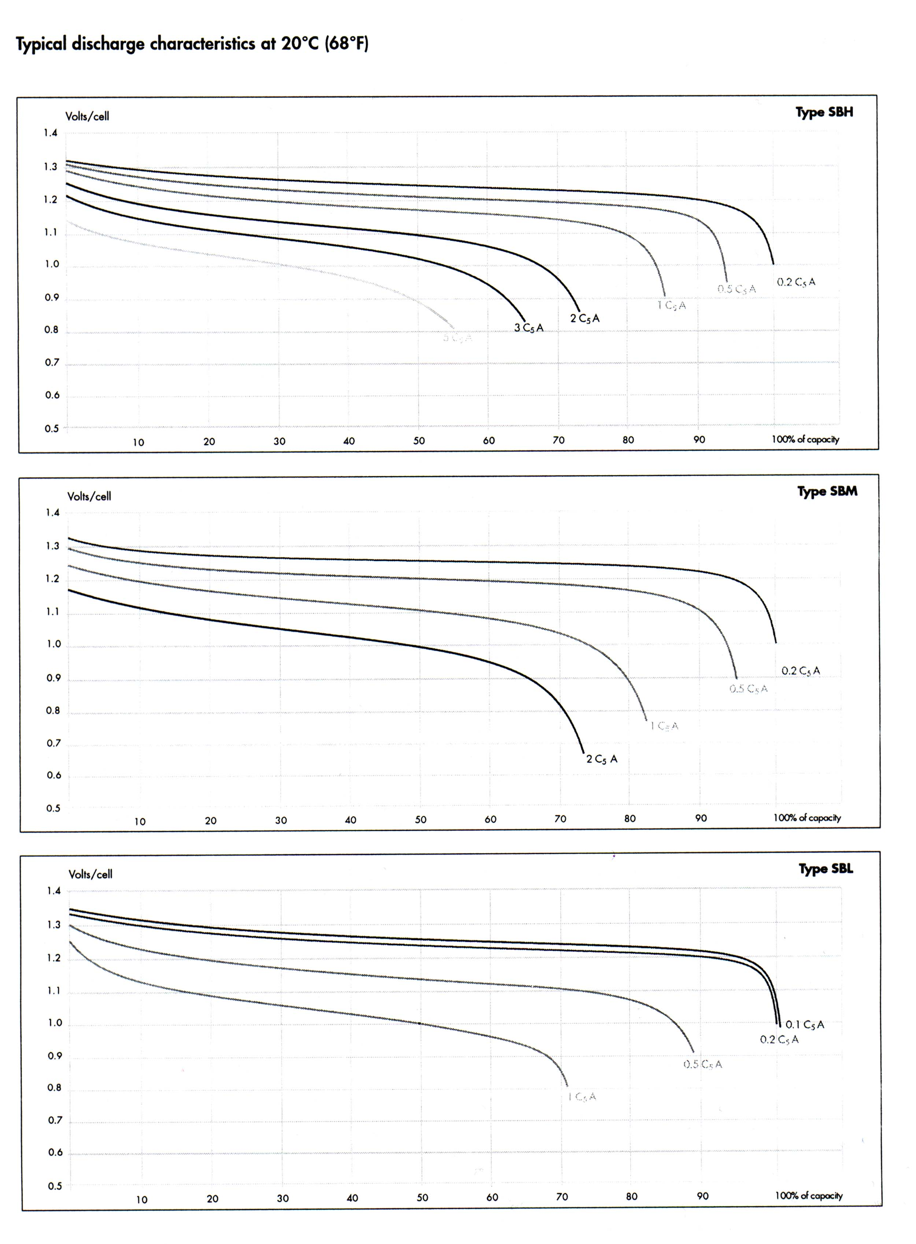
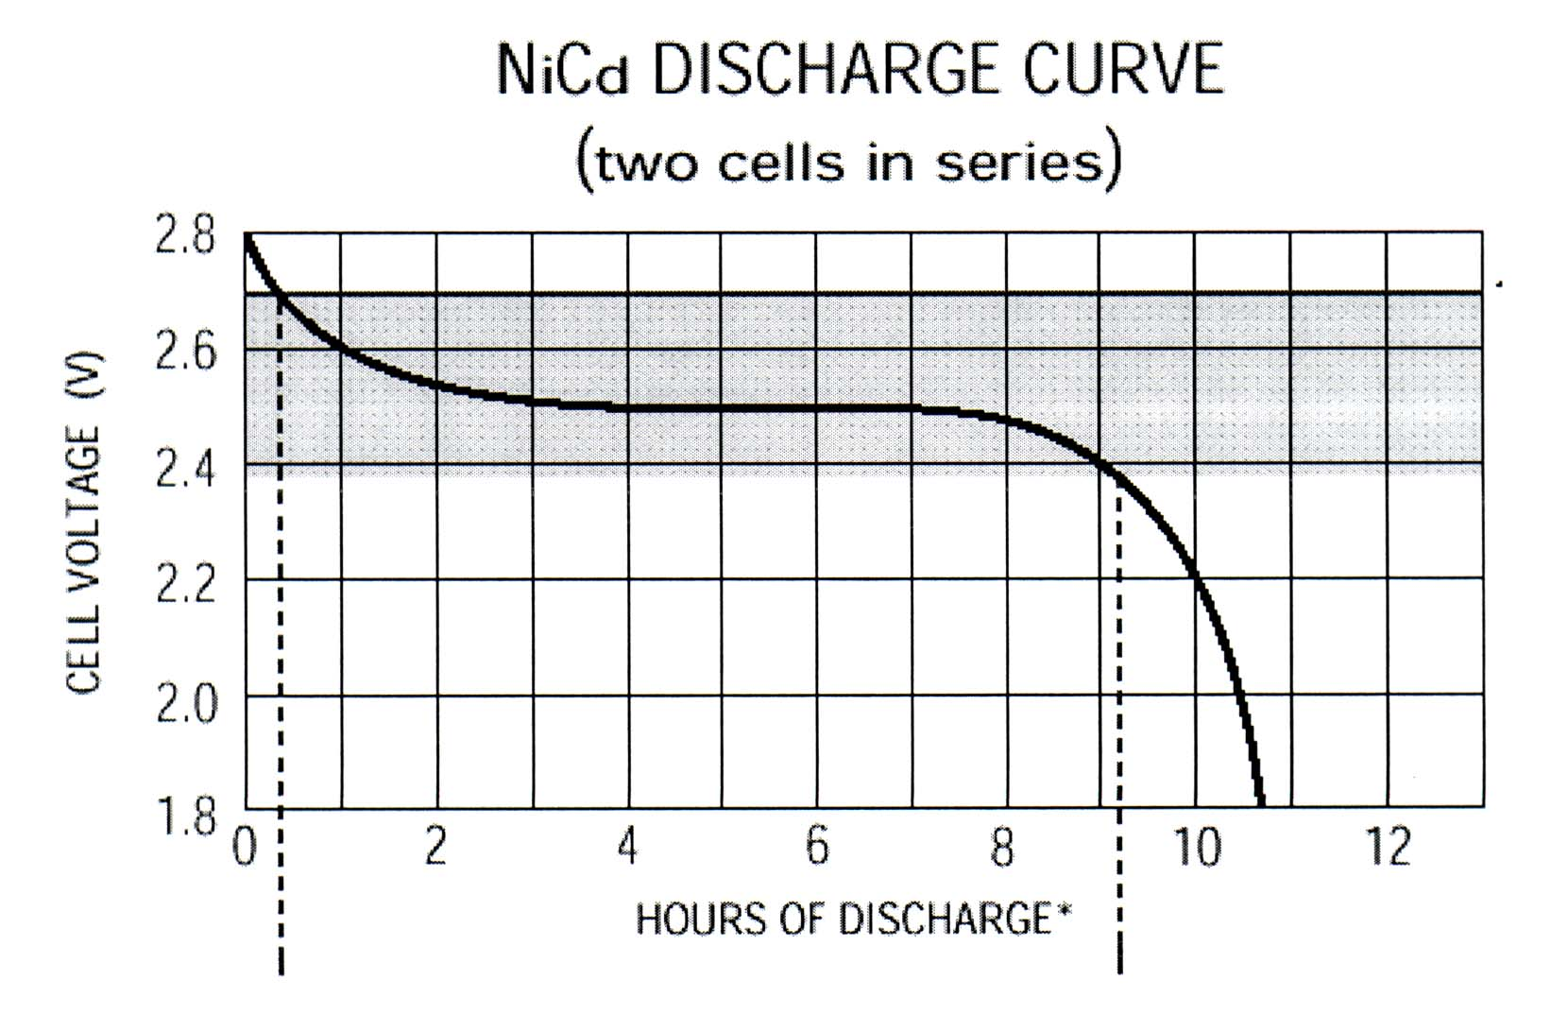

Lithium-Ion Batteries

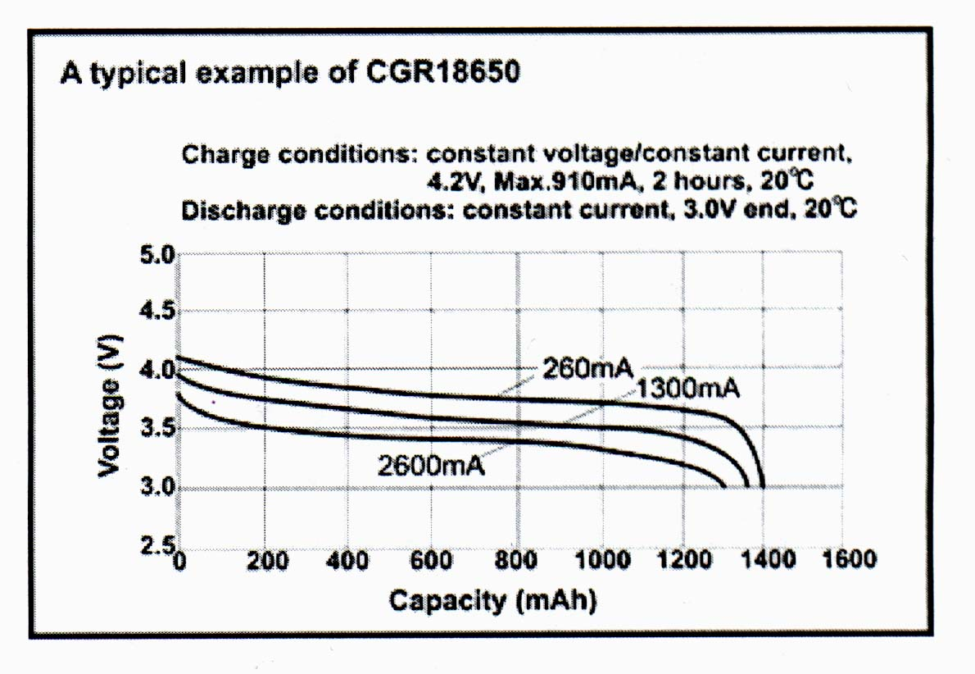
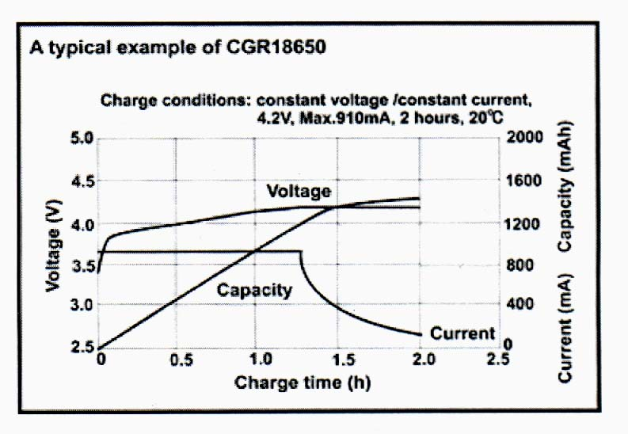

Lead-Acid

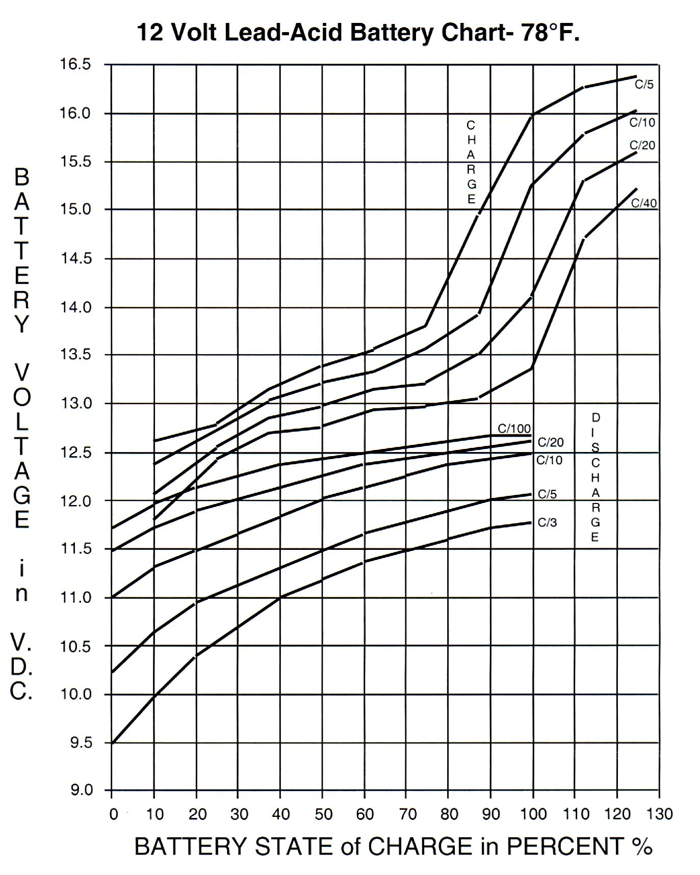

Asmaa Pandit

Jan 30, 2004

PREFERENCES FOR BATTERIES
(keeping money aside)

- Li-Polymer or Li-Ion battery. While still quite rare if scaled up to usable in EV size and up front expensive, at least it became available. Treated right, can be less expensive in a long run than lead acid batteries. Require sophisticated BMS (Battery Management System).

- NiZn battery - relatively new player on the market - comparable to NiMH and NiCd and (recently became) far less expensive.

- NiMH battery. Not available for non-technical reasons, and might never be to you and to me.

- NiCd battery. Realistically available from SAFT (France) or its subdivision ALCAD (Sweden). Expensive up front, but cheap over its long lifetime.

- PbA Gel Cell battery - quite a few choices.

- PbA AGM sealed deep cycle battery - quite a few choices

- PbA flooded battery - many choices.

Fall 03/ Spring 04

NiZn PERFORMANCE FEATURES

NOTE: This battery was chosen for use in Jan 2004 because of the following criteria as below. However, because of availability issues, and more research, we finally decided to use the conventional type: LEAD ACID. In future, this battery (NiZn) may be of good standard use.

Key Performance Features: each of the following constitute major improvements over lead acid batteries:

Environmental Status: This battery technology provides the lowest impact to the
environment of any standard rechargeable battery technology on the market today. Evercel's battery meets the requirements of the EPA for disposal in landfills with regard to heavy metals. A TCLP test has been done by an independent laboratory, which confirms that the Evercel battery does not leach out controllable levels of any heavy metals. Evercel is working on the EU requirements now. Like all of the standard rechargeable batteries, this battery system contains an electrolyte -- an alkaline solution of 20% potassium hydroxide.

Cycle Life: Evercel nickel-zinc batteries can provide 10,000 shallow cycles (10% Depth Of Discharge) and up to 500 very deep cycles (100% DOD) in normal use with approved
charging method.

Weight: For a given amount of energy, such as 10Ah, the Evercel battery is ½ the weight of an equivalent lead-acid battery. If the battery will be used in a high power use, such as a mower or electric vehicle, the actual weight savings would be ¼ the weight of lead.
Nickel-zinc will have equal weight to advanced Nickel Metal Hydride and 30% less weight than Nickel Cadmium batteries of equivalent energy. Today, the nickel-zinc battery's gravimetric energy density with standard cells is 50-60 Wh/Kg.

Volume: For a given amount of energy, such as 10Ah, the Evercel battery is equivalent in size to a lead-acid battery. If the battery will be used in a high power use, such as a mower or electric vehicle, the size would be ½ the size of lead. Nickel-zinc will have equal size to most Nickel Cadmium batteries of equivalent energy. Volumetric energy density depending upon configuration varies from 75 Wh/L to 110 Wh/L.

Temperature Range: Nickel-zinc batteries can operate from -10°C (14°F) to 50°C (122°F) in normal load ranges and performance levels. At very high power the temperature limits are narrower. Charging can be achieved at temperatures from 0°C (32°F) to 40°C (104°F). Charging outside this range is possible but shortens the life of the battery.

Power: Nickel-Zinc batteries are similar to Ni-Cd batteries in the amount of power available. This power is available without significant affect on the capacity of the battery. This is a major advantage over lead acid, which rapidly sacrifices capacity when providing high power. Evercel's high energy system is able to provide peak power of 280 W/kg today and special designs for HEV can provide 500 W/Kg.

Shelf-Life: Evercel nickel-zinc batteries can be be stored at any temperature from -60°C
(-76°F) to +70°C (158°F), without long-term damage. Normal self-discharge, which is
accelerated at higher temperatures and slowed at lower temperatures, will occur. Standard
recharging will recover the lost capacity completely. In same cases, as many as 5-6
charges may be necessary to wake up a battery after long storage. Always fully charge
battery before storage. Expected shelf life of stored batteries is undefined but expected to
exceed 10 years.

Charging Method: Nickel-Zinc cells are charged in an upright position to allow proper
handling of the gases generated during the charging process. Evercel's standard charging
regime is nearly identical to lead acid batteries but uses higher voltage settings and no
trickle charge. It is easily accomplished with reasonable and simple charging systems.
Refer to charging algorithms page of this section by adhering to the algorithms shown, it will ensure a long life and many charging cycles.

Maintenance: There is no required maintenance for this battery. Charging and discharging are the only actions necessary for the use of the battery. The battery is sealed and should not be opened under any circumstances.

Economics: Due to the low initial cost, the high capacity per cycle and the high cycle life, along with no maintenance in the life-time of the battery, nickel-zinc batteries provide excellent economics when compared to other technologies.

Evercel can provide its nickel-zinc technology in a monoblock design or in a single cell
package that can be configuration to suit the customer application.

An in depth technical/scientific report can be downloaded. http://www.evercel.com/featuresofnizn.html

*** *** ***

This 12V 12Ah size is the same as the popular sealed lead acid type of the same Ah. Rating. But though these are two-thirds the weight and expected to last twice as many charge cycles as the lead type, we still haven't conducted sufficient testing to feel comfortable selling them. Better availability than lithium ion but still rare.
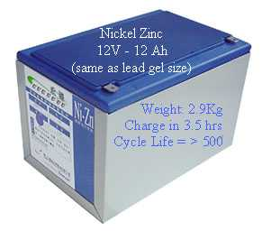

Costing less than Lithium Ion or Nickel Metal Hydride, Nickel Zinc will allow higher amp hours required by e-trikes, e-wheelchairs, e-motorbikes, e-scooters, golf cart type NEVs (Neighborhood Electric Vehicles), and larger electric vehicles requiring more range or less weight than lead acid allows.

Asmaa Pandit
Spring 2004

BATTERY SELECTION REASONS

Finally, after gaining from outside sources, and online research, we came to a conclusion of using LEAD ACID batteries. In Jan 2004, we had decided on NiZn batteries, but because of unavailability issues, we decided to look into more of the conventional type of batteries for use. Refer to the excel spreadsheet for more details on batteries. We have chosen sealed lead acid: Absorbent Glass Mat (AGM) deep cycle batteries over the other batteries because of the following reasons:

- Is easily obtainable
- Reasonably priced
- Conventional: heavy
- Longer life in high temperature applications
- Provides up to twice the life of flooded lead acid batteries
- Lower life-cycle costs
- Reduces corrosion; improves life
- Density 30 Wh/ kg
- 12V ~ 20lbs
- Reliable
- Good charge and discharge curves: produce stable power
- Spill resistant
- Environmentally friendly

The above advantages allows the lead acid batteries to be our first option among our other commercially available choices Even though there are some other types such as Li-ion, that are more efficient and lighter, lead acid provides us with the best option given the specs of our car. As can be seen in the battery Spec excel sheet for Lead Acid, our battery is sealed lead Acid (AGM) deep cycle, part # PVX-3402T.

NOTE: AGM stands for Absorbent Glass Mat battery, which is a type of lead acid battery. It offers reliable performance over a longer life span. Other key benefits include: superior power, vibration resistance, lower life-cycle costs, improved safety, and packaging flexibility. Original equipment manufacturers will also benefit from reduced mass and volume, as well as the possibility to eliminate current heat shield protection.
With all these advantages, deep cycle lead acid batteries also have drawbacks. Lead acid has sulfuric acid electrolyte, produces gas when recharges, and can explode when ignited. It is important also not to mix with salt water because it will produce chlorine gas.

