Lead-Acid Charge and Discharge Curves

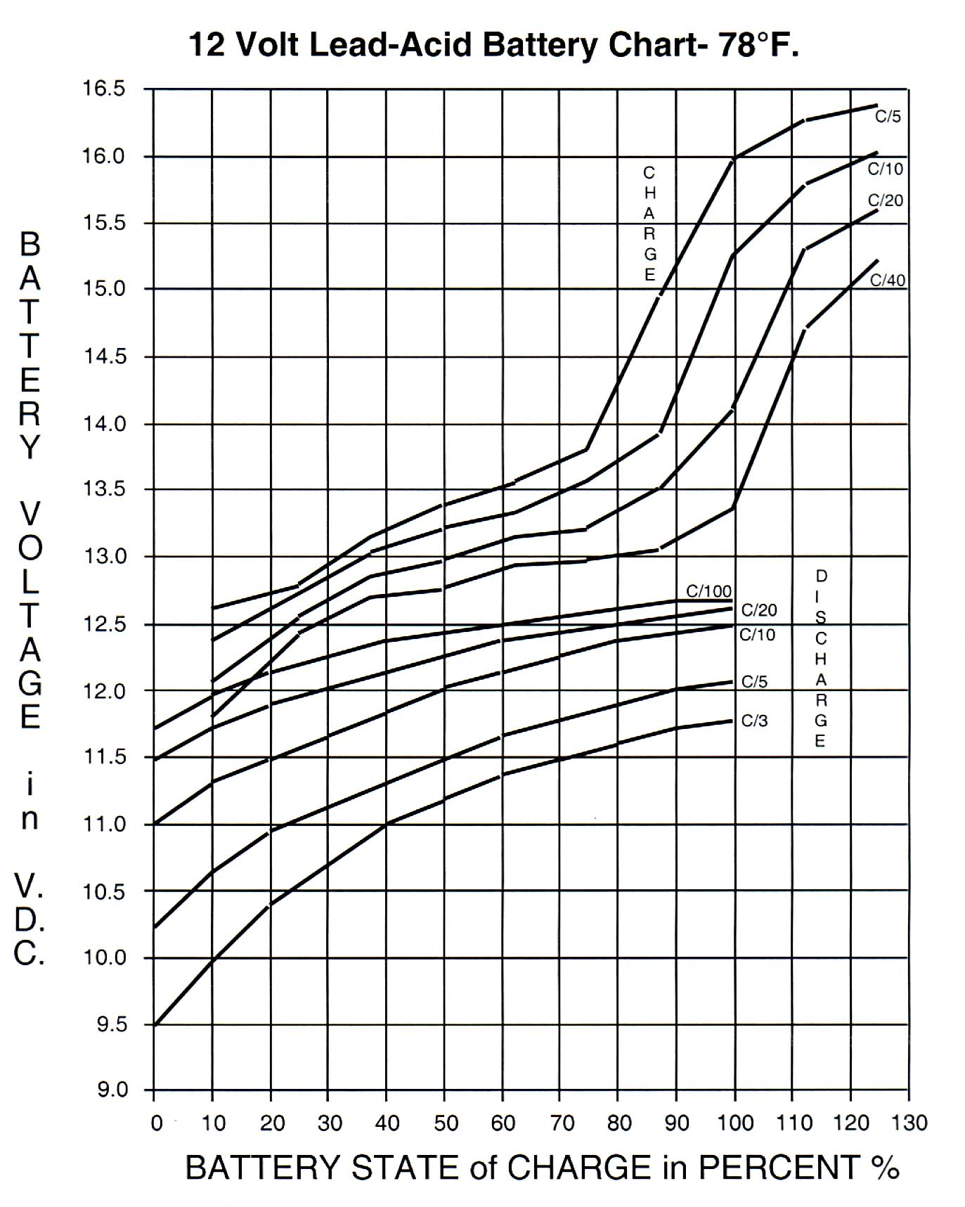

12volt Lead-acid Ampere-Hour Capacity
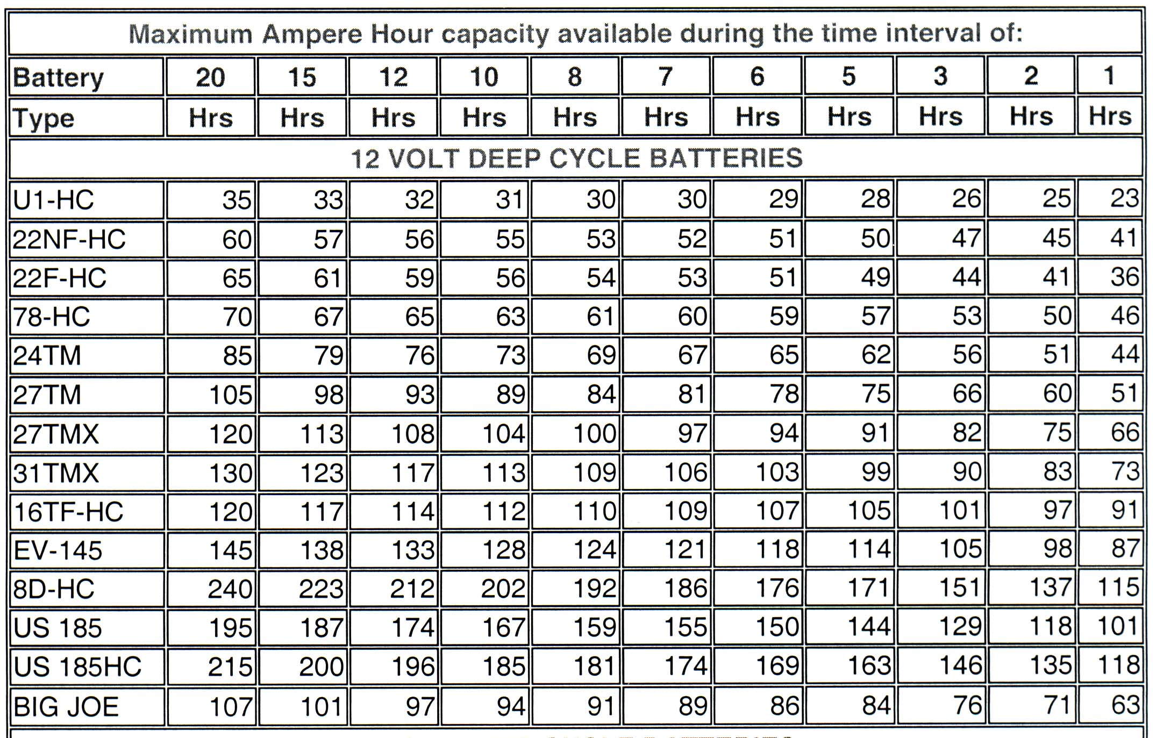

Nickel Metal-Hydride
