Becky Swartz
March 3, 2003

Dimensional Analysis for Cockpit Design

Relevant Dimensions from:
Human Engineering Guide to Equipment Design, Joint Army-Navy-Air Force Steering Committee, McGraw-Hill Company, 1963, Revised 1972 Edition

The following dimensions refer to average army, navy and air force personnel. After compiling this data, the average and extreme lengths were used to set desirable and minimum dimensions for the components of the cockpit for the Anne E.B. Solar Car.

 | Description | Length (5th%) | Length (50th%) | Length (95th%) | pg
A | body depth (male) | 10.1 in | 11.5 in | 13.0 in | 492
B | body breadth (male) | 18.8 in | 20.9 in | 22.8 in | 492
C | sitting eye height | 28 in | 31 in | 33 in | 496
D | sitting shoulder height | 21.5 in | 23.5 in | 25.0 in | 498
E | arm reach (male) | 32 in | 35 in | 37.5 in | 500
F | shoulder breadth (male) | 16.5 in | 18 in | 19.5 in | 501
G | sitting hip breadth (male) | 12.5 in | 14 in | 15.5 in | 509
H | buttock-leg (male) | 38.5 in | 42 in | 45.5 in | 510
I | buttock-knee (male) | 22 in | 24 in | 26 in | 511
J | sitting knee height (male) | 20 in | 21.5 in | 23.5 in | 517
K | depth of arm reach | 19.25 in | 22.25 in | 22.75 in | 535

Please, refer to the figures on the following pages for pictorial explanations of the dimensions.

This data represents dimensions from mostly male samples. Therefore, given that males are typically larger than females, the minimum lengths extrapolated from this data should accommodate females as well.
A 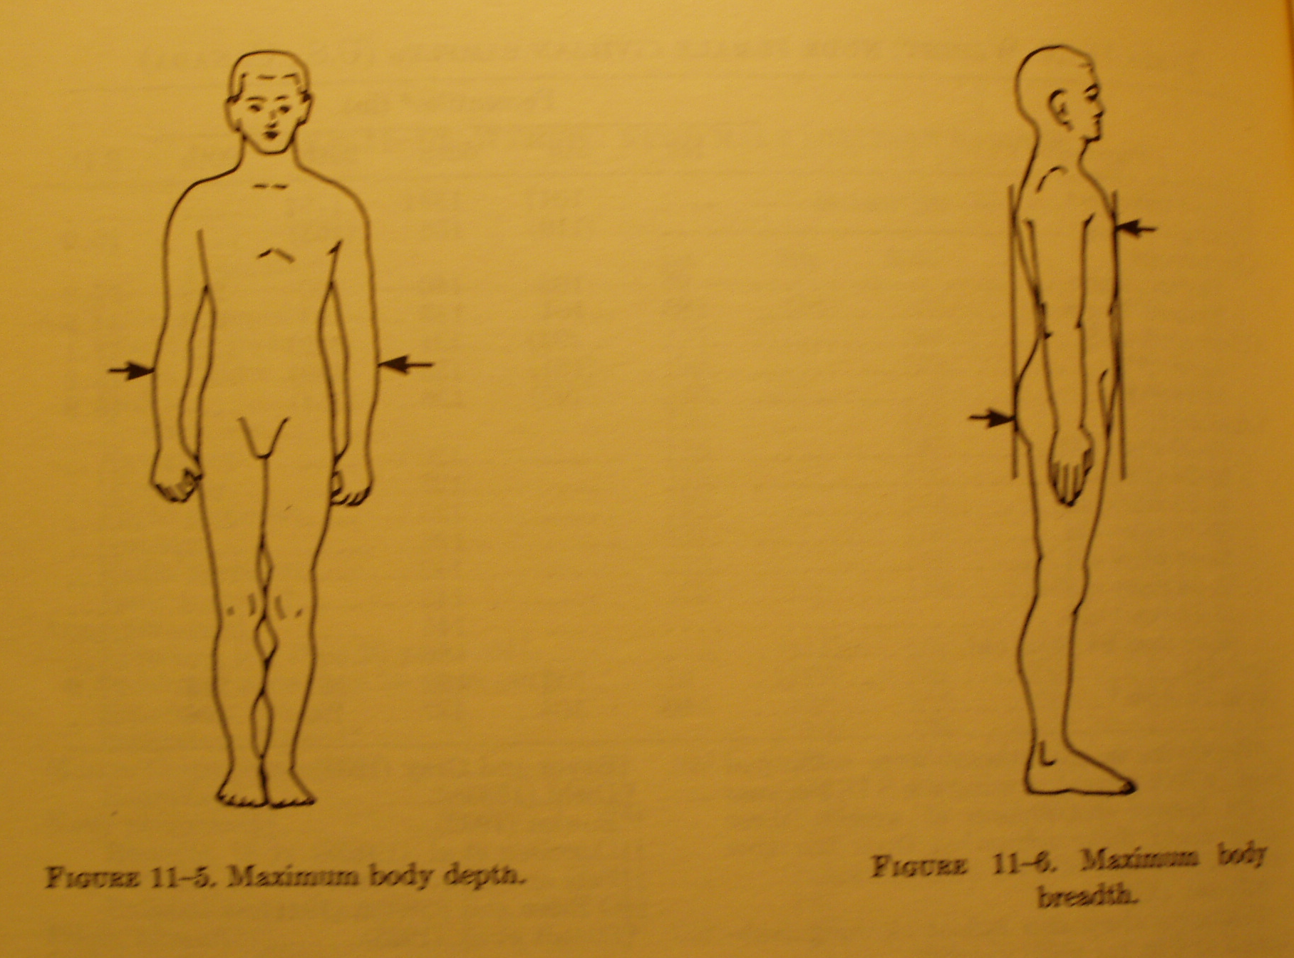 B C 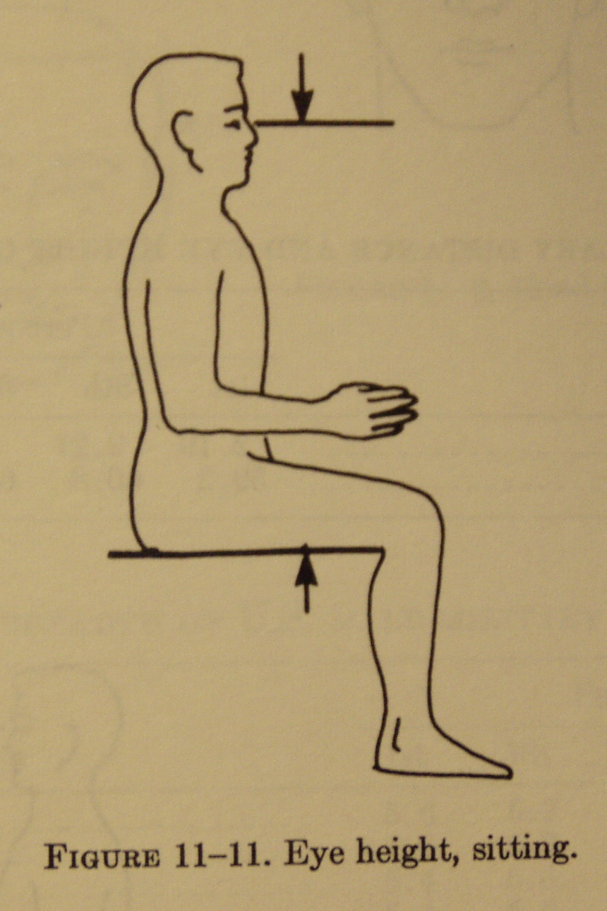
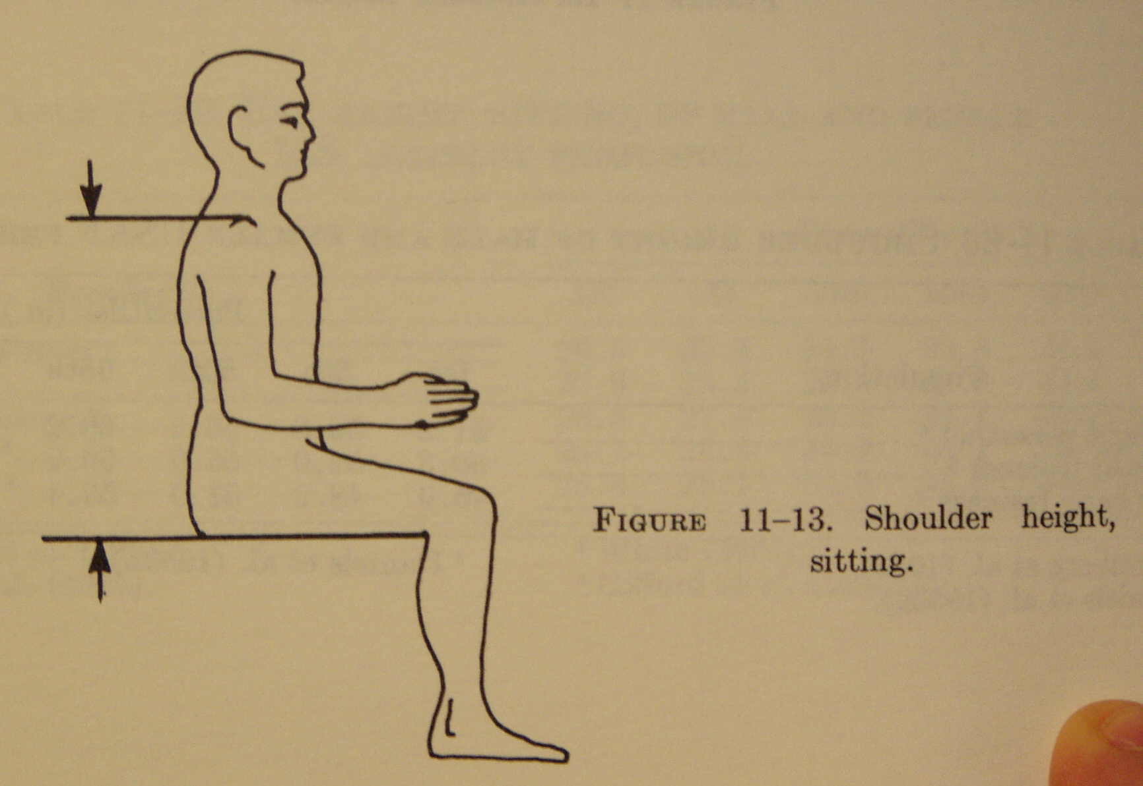 D E 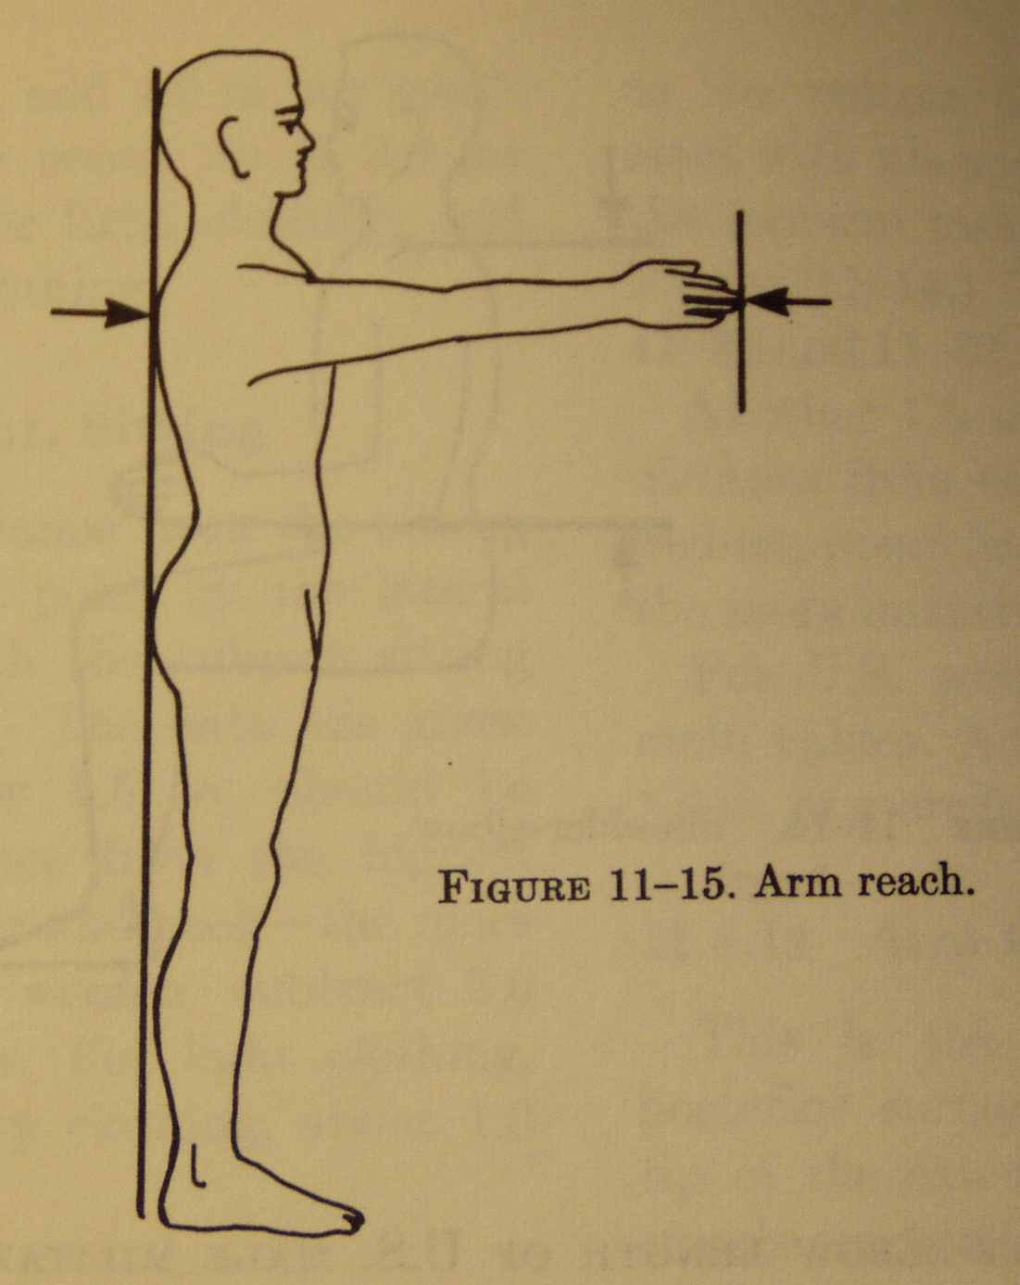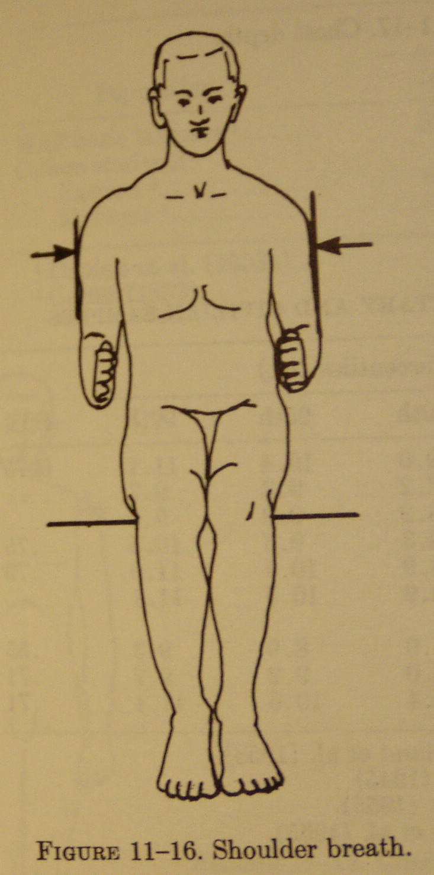 F G 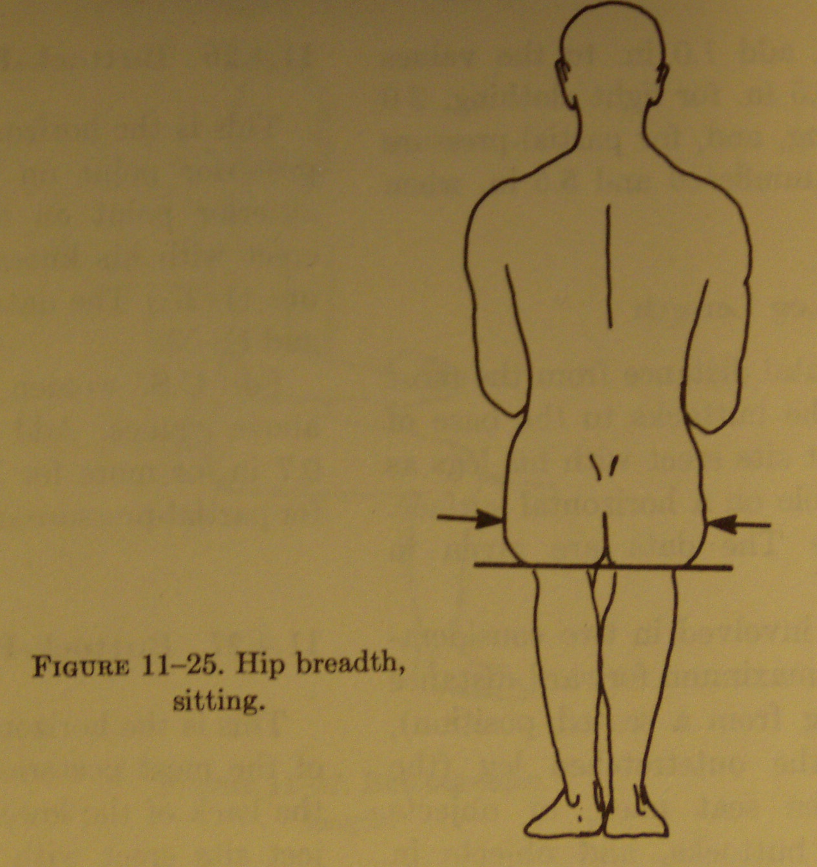
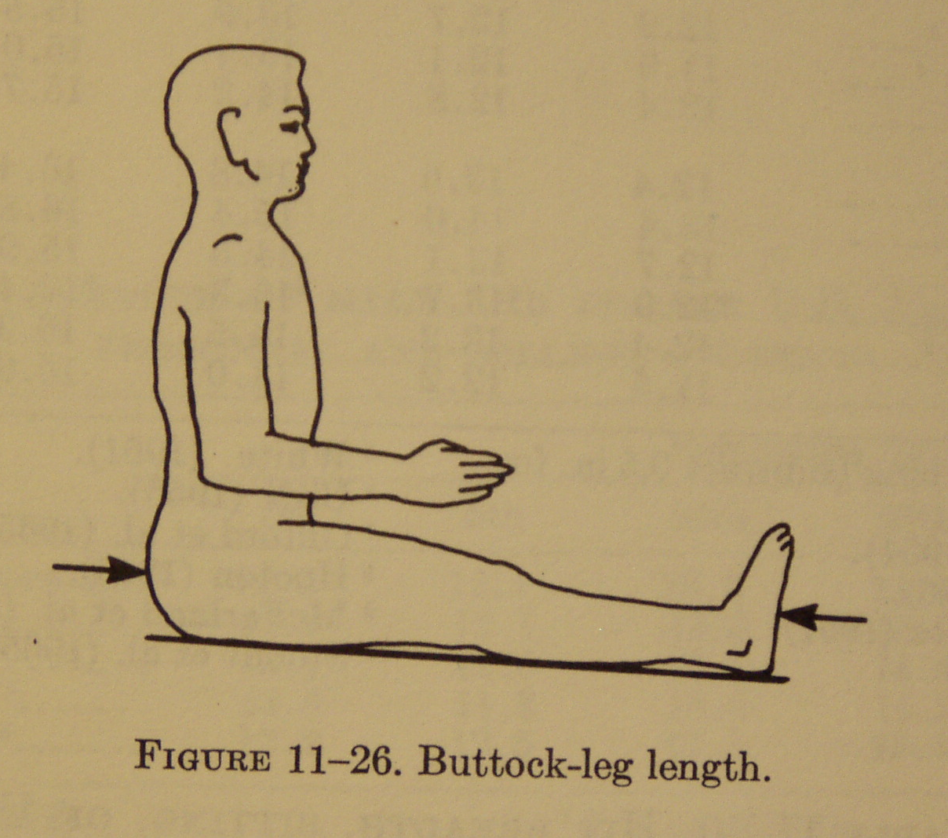 H I 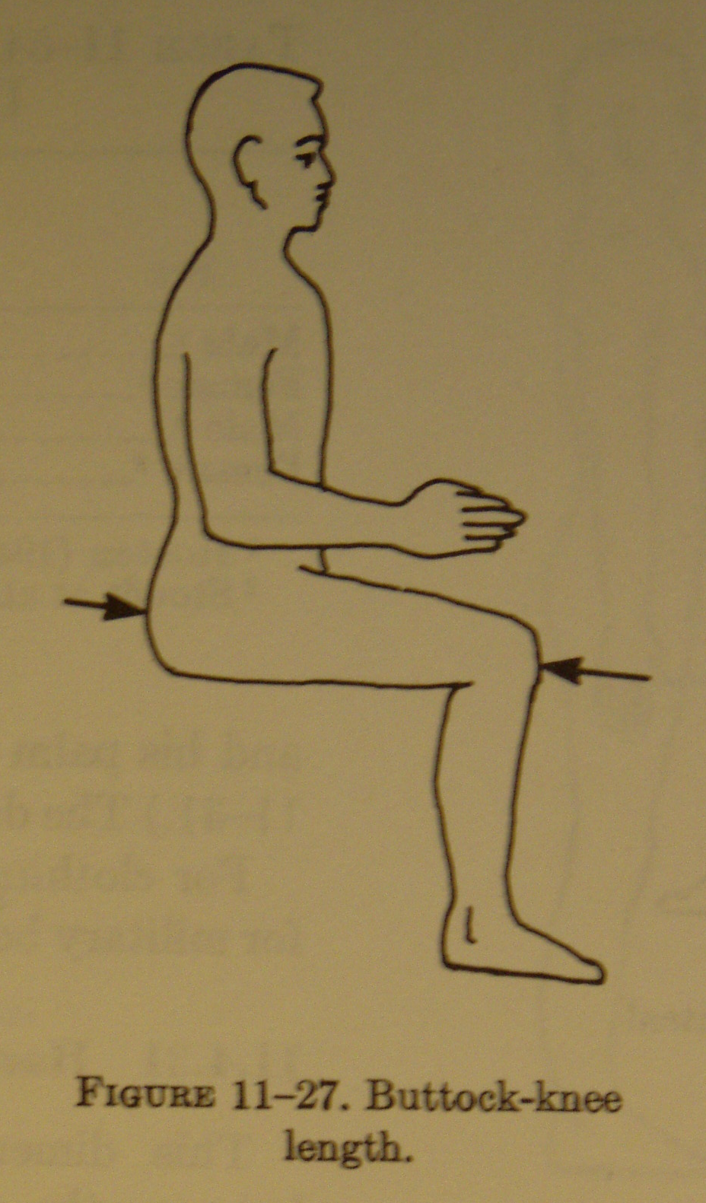
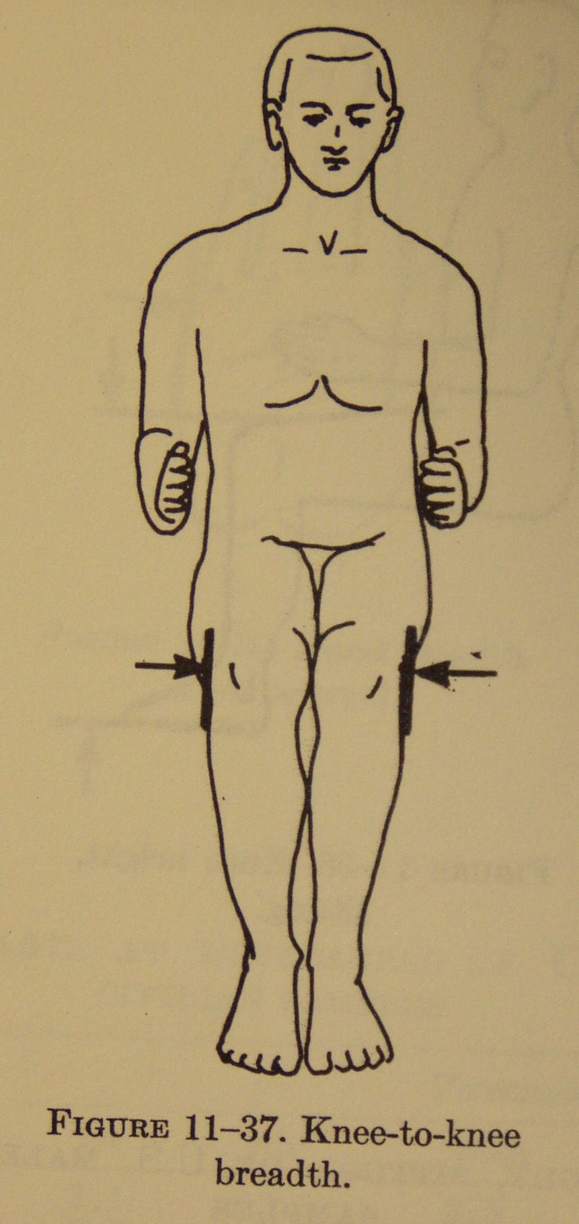 J K 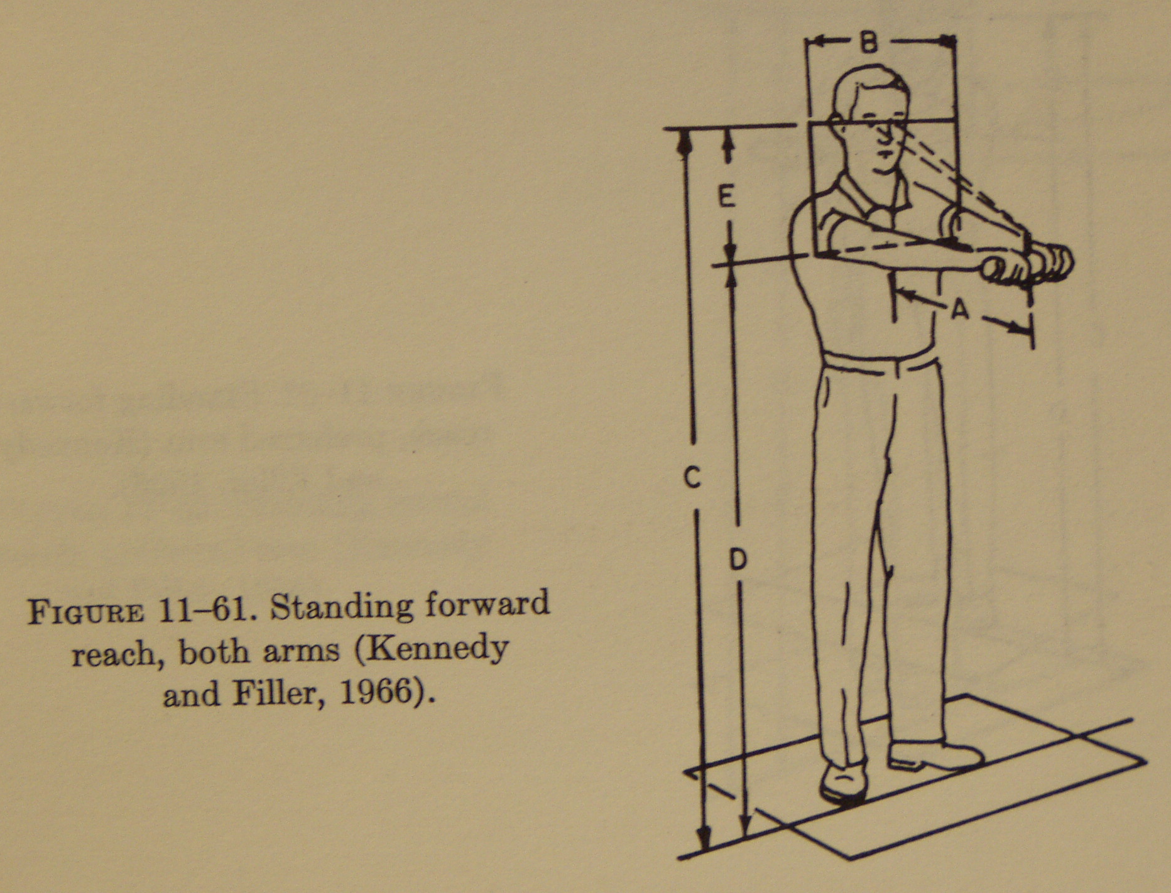
Description of how these dimensions affect the cockpit design: Because the Anne E.B. will accommodate one driver, the width of the cockpit should be at least as wide as the widest part of 95% of the population plus adequate space for controls etc. The male shoulder breadth at the 95% is 19.5 inches. Therefore the minimum width of the cockpit should be 36 inches.

Assuming the driver will be seated in a reclining seat to minimize the height of the car and therefore the drag, the minimum height of the cockpit should be the sitting eye height plus 2 feet. This dimension should be at least 60 inches.

The minimum length of the cockpit should be roughly the sitting eye height plus the buttock-leg length. This dimension should be at least 75 inches.

The seat should accommodate a person of width 16 inches.

The steering wheel should be placed at a minimum distance of 15 inches and no further than 20 inches away so that 95% of people can reach with slightly bent arms and few people cannot reach.

Depending upon the angle of recline, the instruments should be located just below the eye height multiplied by the sin of the angle of recline.


