Tufts University Electrical Engineering Department



Nerd Girls Project Final Report
Emeter Interface
2003-2004

Laurel Hesch

May 10, 2004

Table of Contents:
1. Overview …………………………………………… 3
2. Emeter Interface …………………………………………… 5
2.1 Motivation……………………………………………. 5
2.2 Purpose and Function of the Link-10 Emeter………… 5
2.3 Battery Monitoring……………………………………. 6
2.4 Description of Inputs to the Emeter…………………… 8
2.5 Serial Data…………………………………………….. 9
2.6 Description of Outputs from the Emeter……………… 12
2.7 Transceivers…………………………………………… 12
2.8 Multiplexers…………………………………………… 15
2.9 Microprocessors……………………………………….. 16
2.10 Microprocessor/Multiplexer Functionality…………… 18
2.11 Hardware Functionality………………………………. 20
2.12 Bill of Materials………………………………………. 22
Appendix One: Bill of Materials ……………………………… 23
Appendix Two: Tools Used ……………………………… 24
Appendix Three: Source Code (Emeter Interface)………………… 25
Appendix Four: Source Code (RPM Detection)…………………… 27
Appendix Five: Source Code (Motor Control)…..………………… 29
Emeter Wiring Diagram…………………………………………… 34

1. Overview
In order to build the electronics for the Nerd Girls solar car, several components had to be built. These components, which will each be discussed separately in detail in this investigation, had varying levels of complexity. The simplest systems to build were those which were not interconnected with the others (ie. the lights and the horn). These two systems were independent, and relied only on a power supply and an input from the user to be functional. The higher level systems were the e-meter display, RPM detection, and motor control. These systems were more complex because they were run by microprocessors, and had much more complicated functionality. A high level overview of the data being sent between the systems can be found in figure 1.1. The specifics of each component are neglected in this flowchart, bur a simple overview allows for a higher understanding of the components.

User Input

RPM Detection Signal
Wheel #1
Wheel #2

Serial Data from Emeter #1
Pedal Potentiometer
Light Circuit
Horn Circuit
Serial Data from Emeter #2

Microprocessor #1

Microprocessor #2
Lights
Horn

LCD Display
Motor Controller #1
Motor Controller #2

Motor #1
Motor #2
Figure 1.1: Electrical Systems diagram

2. Emeter Interface
2.1 Motivation
Constructing the electronics for a solar car poses several unique challenges to the electrical engineer. One of the most pertinent obstacles is the reliable monitoring of battery banks. Unlike a gas powered car, where the available energy is simply the physical amount of gasoline present in a tank, the amount of fuel available is determined by the charge on the car’s batteries. Monitoring the amount of juice in a battery is a far more complex problem than monitoring the amount of gasoline in a tank. The reason for this is that battery capacity varies with the amount of current being drawn to power the car. In other words, because of the nature of battery discharge, it is much more difficult to determine when a battery will be empty than when a tank of gas will be empty. For this reason, dedicated battery monitoring devices exist which have the capability of tracking relevant variables. This data, in turn, is passed on to a microprocessor which interprets the raw data and determines how much charge is present on the battery.
This section will discuss how battery monitoring was accomplished for the Nerd Girls Solar Car vehicle.
2.2 Purpose and Function of the Link-10 Emeter
The Link-10 is a battery monitoring device manufactured by Xantrex Technologies. This product, also called an Emeter, is a “smart” battery monitor that outputs a variety of useful information about the current state of the batteries. In the Nerd Girls Solar Car, Link-10 Emeters will be used to keep track of the state of two battery banks at any given moment. This information must be output to a display which is constantly updated when information from the Emeters is received.
A very high level overview of the basic components which had to be synchronized in order to make this system functional can be found in figure 2.1. Each end of the battery bank is connected to the Emeter, which then calculates relevant information and sends it to the microprocessor. The microprocessor passes the relevant information onto a display.
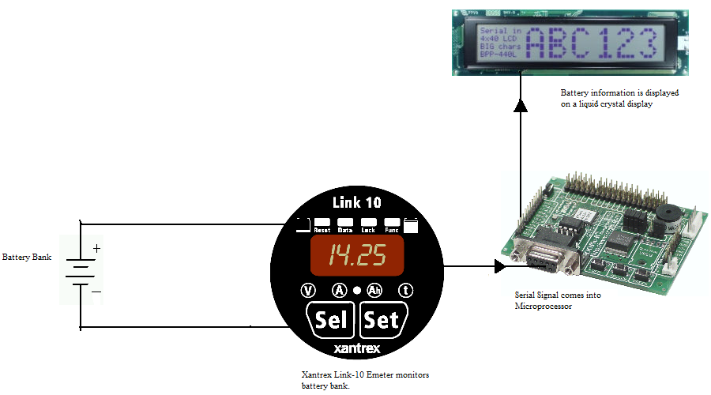
Figure 2.1: A high level overview of the interconnection between components for this interface.
2.3 Battery Monitoring
To accurately keep track of how quickly a battery will discharge, it is important to monitor several variables. The Emeter gathers the kWh, Amps, Volts, Amp-Hours, Peukert Amp Hours, Peukert Amps, and time remaining. Kilowatt hours (kWh) are a measure of the amount of energy present in the battery. One kWh corresponds to one kilowatt of power being used over a period of one hour. The Amps and Volts correspond to the amount of current being drawn at any given point and the difference in electrical potential between the positive lead of the battery and ground. The capacity of a battery to store charge is expressed in Amp Hours. If a battery has the capability of providing 1A for 100 hours, its capacity is 100 Amp-Hours. This rating is useful in determining the amount of charge left in a battery at any time. However, calculating how long a battery will last at a given rate of discharge is not as simple as monitoring the number of Amp-Hours. Battery capacity decreases as the rate of discharge increases. In other words, as more current is drawn from the batteries, the amount of energy a battery can deliver goes down. The formula for calculating how long a battery will really last is called "Peukert's Formula", and is found in equation 2.1.
C_{p}=I^{n} t (Equation 2.1)
C_{p} is called the Peukert’s Capacity, and is the theoretical capacity of the batteries in Amp-Hours. I is the current (in amps), T is time (in hours), and n is the Peukert number for the battery. The Peukert number n is determined by calculating the current at two different times according to equation 2.2.
n=(log t₂- log t₁)/(log I₁- log I₂) (Equation 2.2)
The Peukert number shows how well the battery holds up under high rates of discharge - most range from 1.1 to 1.3, and the closer to 1, the better. The relative discharge rates for three different Peukert numbers is found in figure 2.2. This graph shows that batteries have a much smaller capacity at high discharge rates for high Peukert numbers.

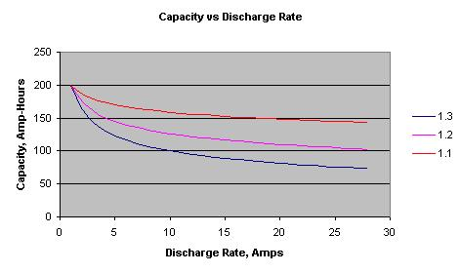
Figure 2.2: A comparison of discharge rates for different Peukert numbers.

2.4 A Description of Inputs to the Emeter
Installing the Emeter involves simply connecting the battery terminals through a shunt as shown in figure 2.3. The two terminals are connected through a jumper shunt for noise immunity, and both wires attached to the positive leads of the battery are attached to a fuse. The fuses prevent power surges from destroying the Emeter. At the bottom of figure 1.3, the connections to the Emeter are shown. Pins one and five coming from the battery bank are dedicated to ground and power, respectively, for the Emeter. The wires on pins 2 and 3 correspond to the Shunt Sense Leads on the battery and load sides. All variables relating to current monitoring are drawn from these two pins. The voltage on the batteries is monitored through pin four, which is the battery volt sensing pin. The Emeters can monitor anything from 0-50 Volts.
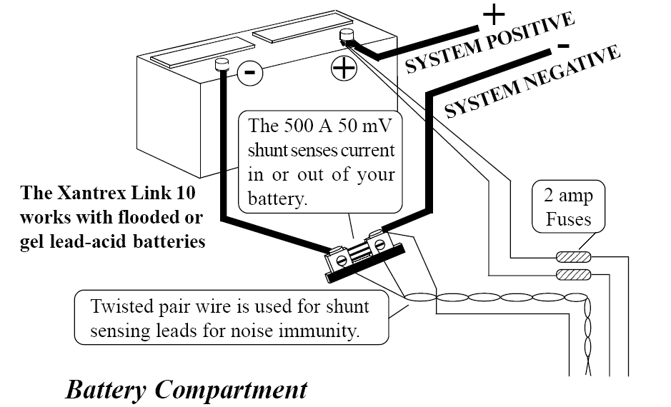
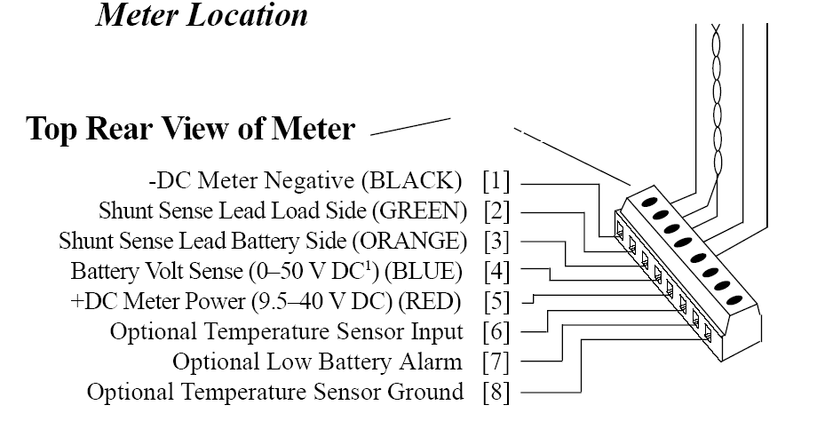
Figure 2.3: Emeter connections in the battery compartment and at meter location.

The emeters have already been connected in the configuration shown in figure 2.3. Future Nerd Girls will simply have to lengthen the wires for the Emeters to properly monitor the car’s battery banks.
2.5 Serial Data
The Emeters send out serial data from a nine pin connector on the back of the device. Before discussing the outputs from the Emeter, a brief discussion of the basics of serial data communication is in order. Serial data transmission is a method of sending and receiving data one bit at a time in a sequential fashion. In order to make equipment from different manufacturers compatible, the RS-232 standard was developed. This standard specifies connections between terminals and modems. A basic scheme for connecting two RS-232 ports involves connecting three wires between two devices. Two of these wires send and receive data in opposite directions, where a third is a common ground. (See figure 2.4 for a diagram of this operation.) To prevent two devices from trying to send and receive data along the same lines, devices which use pin two for output are known as DTE (Data Terminal Equipment), and devices which use pin two for input are called DCE (Data Communications Equipment). DTE devices are referred to as masters and DCE devices are called slaves.
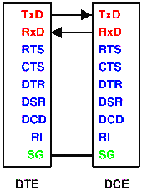
Figure 2.4: Basic RS-232 Functionality
Devices that talk to each other using RS-232 signals operate in full duplex mode, meaning that both devices can transmit and receive data simultaneously. Beyond the simple send and receive wires, optional flow control lines can be connected between two devices. These lines go high when the each device is ready to begin transmissions. The nine standard RS-232 connections are outlined in figure 2.5. In this figure, note the six flow control lines, two data lines, and common ground. See figure 2.6 for the configuration of these pins.
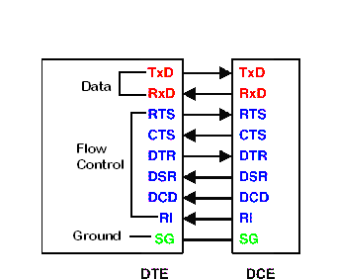
Figure 2.5: Full RS-232 Pinout

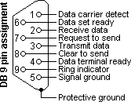
Figure 2.6 Physical layout of DB9 Pins for a DTE Device
In order to send and receive data over distances of up to 50 feet, RS-232 signals operate between +5 and +15 volts for high (logical one) signals and –5 to -15 volts for low (logical zero) signals. Typical voltage levels for RS-232 signals are ±12 Volts. For lower-power applications, Transistor-to-Transistor Logic (TTL) signals are used. These signals operate between zero and five volts, with any voltage above 3.5 volts operating as a logical one. TTL signals are typically used by microprocessors powered by a five-volt supply. These signals are used for short-range data transmission between logic devices.
2.6 A Description of the Outputs from the Emeter
Emeters have a DB-9 connector (see figure 2.6) and send out serial RS-232 data every second. The data output is time, kWh, Amps, Volts, Amp Hours, Peukert Amp Hours, Peukert Amps, time remaining, and bar graph state. This data is sent at 9600 baud, 8 data bits, 1 stop, no parity. The pinout for this connector is as follows:
Pin 2: Receive Data Line
Pin 3: Transmit Data Line
Pin 5: Ground
The transmit data line and ground were connected to the rest of the circuitry. One suggestion for future work is that it might be helpful to connect the transmit pin and write some routines for configuring the Emeters from the microprocessor. The two devices used to interface the Emeters with a microprocessor were transceivers and multiplexers. The next two sections will discuss these devices in detail.
2.7 Transceivers
As discussed in section 2.5, two possible ranges of voltage can be used to transmit and receive serial data. RS-232 signals are used for long ranges, and TTL levels are used for microprocessor-level logic. When an RS-232 device and a TTL device talk to one another, the voltage from one device must be ramped up or down so that the devices operate at the same voltage levels. The reason for this is that if signals between ±12 Volts were fed into pins which were configured for 0-5 Volts, the high voltage and current would blow out the circuitry of the lower voltage device. Each device used in this project required a different voltage level (see table 2.1)

Device | Voltage Level fo r Operation
Emeter | ±12 Volts
Multiplexer | 0-5 Volts
OOPic DB-9 Connector | ±12 Volts
Oopic-R Microprocessor | 0-5 Volts

Table 2.1: Voltage requirements for devices.
In order to not burn out the multiplexers and microprocessors, it was necessary to use a transceiver to ramp down the high voltage RS-232 output from the Emeters. A Maxim Max 208 transceiver was used. The pinout for this device can be found in figure 2.7 and the external capacitor configuration can be found in figure 2.8. See the pinout diagram for this section in the appendix of this report. Once the transceivers were connected to the appropriate 1mF capacitors and powered up according to the schematic in figure 2.7, ramping down voltages involved connecting any RS-232 level serial signal to an RS-232 input (ie. pins 7, 3, 23, or 16) and wiring the output up to the corresponding TTL output (ie. pins 6, 4, 22, 17). Similarly, to ramp up voltages, it is only necessary to connect a TTL input (ie pins 5, 18, 19, 21) to the corresponding RS-232 output (ie pins 2, 1, 24, 20).
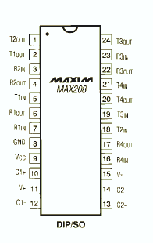
Figure 2.7: Pinout for Transceiver
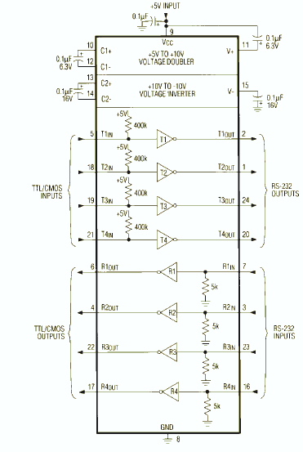
Figure 2.8: Diagram of Transceiver functionality and capacitor pinout.
2.8 Multiplexers
A multiplexer, or mux, is a device that combines several electrical signals into a single signal. There are different types of multiplexer for analogue and digital circuits, but the most simple is a two channel multiplexer with a single select line. A multiplexer allows data to be passed through one of two channels according to the state of a select line. In other words, when the select line is low (0 Volts) data from B will be sent to the output of the multiplexer, where data from A will be ignored. Similarly, when the select line is high (5 Volts), data from A will be sent to the output of the multiplexer where the data from B will be ignored. A truth table and K-map for multiplexer operation can be found in figures 2.9 and 2.10, where S is the select line and A and B are the two inputs.
A B S | Y
------+--
0 0 0 | 0 (pick B)
0 0 1 | 0 (pick A)
0 1 0 | 1 (pick B)
0 1 1 | 0 (pick A)
1 0 0 | 0 (pick B)
1 0 1 | 1 (pick A)
1 1 0 | 1 (pick B)
1 1 1 | 1 (pick A)
Figure 2.9: Truth Table for a Multiplexer
Y S
| 0 1
---+-----
AB 00 | 0 0
01 | 1 0
11 | 1 1
10 | 0 1

Figure 2.10: Karnaugh Map for a Multiplexer
In this project, a 4:1 multiplexer was used. See figure 2.11 for a diagram. The input lines are indicated by I0, I1, I2, and I3 in this diagram, and the chip selects are indicated by C1, and C0. The output is denoted by Y. For this project, it was necessary to alternately read serial data in from two channels, meaning that one of the chip selects was disabled, and only two of the inputs were used. Essentially, a 4:1 mux was used to emulate a 2:1 mux.
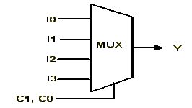

Figure 2.11: 4:1 Multiplexer
2.9: Microprocessors
The microprocessors which were used in this project were encapsulated into an integrated circuit board with built in firmware. In other words, instead of using just a physical microprocessor, circuits were purchased which already contained physical pins, voltage regulators, LED’s and speakers. Object-oriented PIC16F877 chips (oopic) were used because of their high level of flexibility and the amount of technical support available from other hobbyists. The Oopic-R evaluation boards features 31 IOlines, built in analog to digital conversion, and serial communications capability. A voltage regulator, speaker, and status LED’s were included on the evaluation board. Finally, object-oriented firmware specifically configured for electronics applications was embedded on the PIC microcontrollers. The oopic-R’s advantages over the Basic Stamp (another simple off-the shelf microprocessor integrated circuit) include a larger number of IO Lines, networking capability, and a more flexible programming environment. The object-oriented platform resulted in simple coding algorithms. The features of the Oopic-R are shown in figure 2.12, and a more technical pinout is found in figure 2.13.
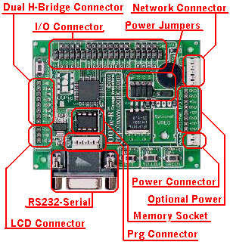
Figure 2.12 OOpic-R board

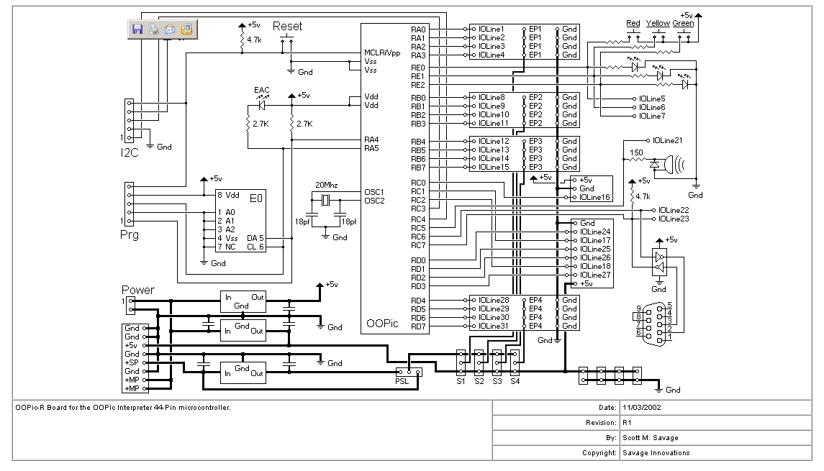
Figure 2.13 pinout to oopic-R board
Oopics are programmed in Basic, which is a simple to understand programming language. These microprocessors also include 130 built in objects. The way that objects work is that the code for a specific functionality is given a name. When this name is declared, all of the code to initialize this functionality is enabled. An example of this is the Liquid Crystal Display (LCD) interface used in this investigation. Normally, initializing an LCD involves initializing serial communications between two devices, declaring or disabling select lines, and choosing a baud rate. Since almost all LCD’s use the same baud rate and select line configurations, the oopic encapsulates this code into a pre-defined object. Therefore the user only needs to declare an LCD object for all of this code to take place. An example of the simplicity of coding is in figure 2.14.

'This program prints "Hello”
'To an LCD

Dim A As New oLCDSE

Sub Main()
A.IOLine = 8
A.Clear
A.String = "Hello"
End Sub

Figure 2.14: Object-Oriented Programming Example
In order to write data to an LCD, the user must only specify the input/output line which the LCD is connected to. The rest of the code is automatically defined within the object. Some useful references for Oopic-R microprocessors are discussed and referenced in Appendix Two.

2.10 Microprocessor/Multiplexer Functionality
Because of a variety of timing and hardware constraints, a PIC microprocessor can only “listen” to one serial signal at a time. The reason for this is that the timing is so specific for serial signals that microprocessors must use dedicated devices to interpret serial communications. This type of device is called a UART, and a Oopic-R has only one. Therefore, a multiplexer was used to “feed” two serial signals into one UART. It was determined that it is not necessary for the microprocessor to gather all data from both Emeters every second. Battery information does not change fast enough that this is necessary. A refresh rate as low as a minute would be acceptable for the information sent from the Emeters. The select line on the multiplexer was directly from the input/output pins of the PIC. A dedicated output pin was connected to the microprocessor select line, and every time the PIC program wanted to read from a different Emeter, this line was toggled.
The functionality of the program that reads the voltage in from the Emeter can be found in figure 2.15. The basic way the program works is that the mux line is set low (this allows the data to be read in from one e-meter output), and the program waits for a carriage return. A carriage return (or ASCII 13) is the last character in one of the Emeter transmissions. So that the microprocessor doesn’t start to read data in during the middle of a transmission, data is ignored until a carriage return is received. Then, once this character has been received, we are sure that the next data will be the beginning of a transission. Some of the data which the Emeter sends out is redundant (such as Amp-Hours versus Peukert Amp-Hours). As the Peukert Amp-Hours is a more relevant measure of how long the batteries will last, the conventional Amp-Hour calculation was ignored. The relevant variables were formatted and passed on to the LCD, and irrelevant variables ignored. The next step the program followed was for the PIC to toggle the select line and read data in from the other Emeter in the same manner.

Set mux select line low
Ignore data in until a carriage return is received.
After a carriage return is received, read in data and display it to the LCD by ignoring irrelevant bits and passing relevant ones to the display.

After a carriage return is received, read in data and display it to the LCD by ignoring irrelevant bits and passing relevant ones to the display.

Ignore data in until a carriage return is received.
Set mux select line high

Figure 2.15: Program Functionality
2.11 Hardware Functionality
While the functionality of the system and the reasoning behind the use of a multiplexer was covered in the previous section, a discussion of the hardware necessary to implement this design is also in order. A block diagram of the hardware components of this project is found in figure 2.16. Besides a multiplexer, it was necessary to ramp the voltage up and down several times using a transceiver. As discussed in section 2.7, transceivers were used to ramp up and down the voltage between components. Table 2.1 displays the voltage requirements for each device. It was necessary to ramp the serial signal from up or down three times before it was fed into the Oopic-R board. The ±12 Volt transmission from the Emeter was ramped down to 0-5 Volts and passed through the multiplexer. Then, the signal was ramped up again to ±12 Volts to be fed into the DB-9 hookup on the Oopic. The Oopic’s internal UART then ramped the voltage down again to the levels necessary for interface with the microprocessor. This approach was unnecessarily confusing and could have been avoided if ±12 Volt multiplexers existed. However, they don’t, and for the transmissions from the Emeters to be sent through two channels, the voltage had to be ramped up and down in this manner.
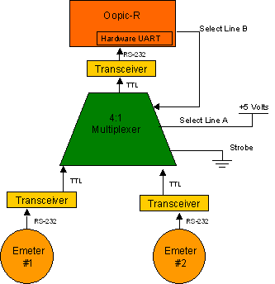
LCD Display
TTL Serial Data to LCD

Figure 2.16: Block Diagram of Functionality
The final piece of hardware used in this setup was a BPP-440L 4x40 serial LCD from Scott Edwards Electronics. To connect the Oopic to the LCD, three wires must be connected: signal, power, and ground. Once these three wires are connected, data can be sent by simply declaring a serial LCD object on the Oopic. See appendix three for examples of how to write the LCD code.

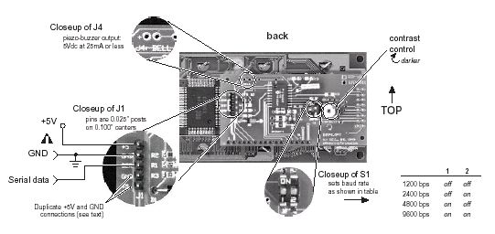Figure 2.17: Hardware Pinout to the LCD
2.12 Bill of Materials for Emeters
Item | Quantity | Cost
OOpic-R board | 3 | $79.00
Maxim Max 208 transceiver | 1 | $7.55
Xantrex Link 10 e-meter | 2 | $304.69
Scott Edwards  4x40 Serial LCD Display  Part Number BPP-440L | 1 | $159.00
SN74LS153 4:1 Multiplexer | 1 | $0.45

Appendix 1: Bill of Materials

Item | Quantity | Cost
OOpic-R board | 3 | $79.00
Maxim Max 208 transceiver | 1 | $7.55
Xantrex Link 10 e-meter | 2 | $304.69
Scott Edwards  4x40 Serial LCD Display  Part Number BPP-440L | 1 | $159.00
LCD Display | 1 | $50
Brushless Motor (HCMC-48 VDC/100A) | 1 | not purchased by group
Generator Controller | 1 | not purchased by group
Hall-Effect Sensors | 3 | $20
Horn Bocina Avertissuer | 1 | $13
Universal Horn Button | 1 | $5
Mini 10 Amp Fuse | 1 | $3
Double Pull Double Throw Switch | 1 | Electrical Engineering Dpt. ($0)
Double Pull Single Throw Switch | 1 | Electrical Engineering Dpt. ($0)
Breadboard for prototyping | 1 | $10.97
Breadboard for prototyping | 2 | Electrical Engineering Dpt. ($0)
555 Timer | 1 | Electrical Engineering Dpt. ($0)
SN74LS153 4:1 Multiplexer | 1 | $0.45
Magnets | 8 (2-packs) | $5
Digital Potentiometer | 2 | $2.22
10K-Ω Resistor | 1 | Electrical Engineering Dpt. ($0)
11K-Ω Resistor | 1 | Electrical Engineering Dpt. ($0)
15K-Ω Resistor | 1 | Electrical Engineering Dpt. ($0)
.47 μF Capacitor | 1 | Electrical Engineering Dpt. ($0)
1mF Capacitors | 5 | $0.37
Primary Wire- 14 Gauge | 1 | $4
Appendix 2: Tools Used

1. Compiler Program: The compiler program used was made by oopic and is available for free download at: http://oopic.com/dloadp.html
The self extracting zip file “OOPicFV304.exe” was downloaded. Please note that this version works for Windows XP as well as earlier versions of windows.

2. Programming Cable: A DB-9 female to male RS-232 cable was used to connect the COM port of the PC to the DB-9 connector on the OOPic-R integrated circuit.

3. A DC power source was used to provide a 9V power supply to the PIC board. Please note there is a built in voltage regulator on the OOPic which allows for voltages between 5 and 15 volts to successfully power the PIC.

4. The book Programming and Customizing the OOPic Microcontroller by Dennis Clark was an invaluable resource for OOPic programming. This book was published by McGraw-Hill/TAB Electronics in 2003.
Appendix 3: Source Code (Emeter Interface)
'Laurel Hesch
'Nerd Girls
'Spring 2004

'This code reads values in from the two emeters (interfaced through the transceiver and the mux)
' and displays them on the LCD

dim emeter as new oserialport
dim red as new odio1
dim yellow as new odio1
dim sel_line as new odio1
dim lcd as new olcdse
dim dummy as byte
dim i as byte

sub main()
dim count as new obyte
'initialize LCD
lcd.ioline = 16
lcd.operate =1

'initialize serial in from the RS-232 port pin 22
' (note: this is the top middle pin on the DB-9 connector)

emeter.baud=cv9600
emeter.operate=cvtrue

'initialize LED's
red.ioline=7
red.direction=cvoutput
yellow.ioline=6
yellow.direction=cvoutput

'initialize select line
' Low is emeter #1
' High is emeter #2
sel_line.ioline=5
sel_line.direction=cvoutput

do
'------------------------read from emeter 1----------------------------
'read from the first channel by setting the select line low (emeter #1)
sel_line=0

'a carriage return indicates the end of the previous
'transmission
waitfor_cr
'ignore the first 7 bytes of the transmission (they are
'irrelevant information)
wait_bytes(7)

read_in_vals

'------------------------read from emeter 2------------------------------------
'read from the second channel by setting the select line high
'(emeter #2)
sel_line=1
'a carriage return indicates the end of the previous
'transmission
'ignore the first 7 bytes of the transmission (they are irrelevant information)
wait_bytes(7)
'read in the values and display them on the LCD
loop
read_in_vals
end sub

'This sub reads all data into a dummy variable until a carrige return is 'received
'A carriage return indicates an end of transmission.
'This behavior ensures that data is only relevant data is displayed on the LCD.

sub waitfor_cr()
do until emeter.value=13
loop
dummy = emeter.value
end sub

sub wait_bytes(bytes as byte)
for i= 0 to bytes
'ignore x bytes of data (note the program pauses here to wait 'for data)
dummy = emeter.value
next i
end sub

sub read_in_vals
lcd.value = 12
lcd.string = "kWh: "
for i = 1 to 5
lcd.value = emeter.value 'read kwH out to the LCD
next i
wait_bytes(1)
lcd.string = "Amps: "

for i = 1 to 6
lcd.value = emeter.value 'read Amps out to the LCD
next i
wait_bytes(1)
lcd.string = "Volts: "

for i = 1 to 5
lcd.value = emeter.value 'read Volts out to the LCD
next i

wait_bytes(1)
lcd.string = "Amp Hours: "

for i = 1 to 6
lcd.value = emeter.value 'read Amp Hours out to the LCD
next i
wait_bytes(17)
lcd.string ="Time Remaining: "

for i = 1 to 5
lcd.value = emeter.value 'read Time Remaining out to the LCD
next i
end sub

Appendix 4: Source Code for RPM Detection

'Sharon Smith
'This program reads the analog value from I/O line 2.
'From this value it calculates the number of revolutions per minute 'and outputs it on an LCD display.
Dim Input As New oA2D
Dim Output As New oDio8
Dim Red As New oDio1
'Dim InputCounter As New odio8
Dim InputCounter As New oByte
Dim A As New oByte
Dim B As New oByte
Dim Tick As New oClock
Dim ClockInterrupt As New OEvent
Dim Green As New oDio1
Dim ClockCounter As New oByte
Dim flag as new oByte
Dim RPM as new oWord
Dim Previous as new oByte
dim lcd as new olcdse
Sub Main()
'------Magnet Trigger Initialization---------------------------
InputCounter = 0
A =0
B= 0
Red.IOLine=7
Red.direction=cvoutput
Output.IOGroup = 1
Output.Direction = cvOutput
Input.ioline = 1
Input.operate = 1
'---------Clock Initialization----------------------------------
ClockCounter = 0
Tick.Rate = 90 'Frequency = 283/ (256 - Rate)
Tick.Mode = 1
Green.IOLINE = 5
Green.Direction = cvOutput
Tick.Output.Link(ClockInterrupt.Operate)
'-----------Start Interrupts---------------------------------
Tick.Operate = cvTrue
Do while B < 6
Output.Value = Input.Value
if Input.Value = 0 then
Red= cvon
InputCounter = 1
elseif input.value = 1 then
Red= cvon
InputCounter = 1
Else
Red = cvoff
InputCounter=0
End if
If InputCounter = 1 then
if not Previous and InputCounter then
A=A+1
end if
End If
B =ClockCounter
if B=5 then
RPM=A*12
A=0
ClockCounter=0
B=6
end if
Previous=InputCounter
loop
'----------------Output value onto lcd-------------
dim hundreds as new oByte
dim tens as new oByte
dim ones as new oByte
hundreds= ((RPM/100) mod 10) +48
lcd.value=hundreds
oopic.delay=10
tens= ((RPM/10) Mod 10) +48
lcd.value=tens
oopic.delay=10
ones= (RPM Mod 10) +48
lcd.value=ones
oopic.delay=10
oopic.delay=100
lcd.clear
end sub
Sub ClockInterrupt_Code()
Green.Invert
ClockCounter = ClockCounter + 1
End Sub
Appendix 5: Source Code for Motor Control

'Emily Mower
'May 1, 2004
'This program controls the motors by altering
'the output potentiometer values P1 and P2

Dim Green as New oDio1
Dim Red as New oDio1
Dim Yellow as New oDio1
dim RPM1 as new oWord
dim RPM2 as new oWord
dim RPMstd as new oWord
dim P1 as new oDio1
dim P2 as new oDio1
dim PP as new oA2D

Dim Input As New oA2D
Dim Output As New oDio8
Dim InputCounter As New oByte
Dim A As New oByte
Dim B As New oByte
Dim Tick As New oClock
Dim ClockInterrupt As New OEvent
Dim ClockCounter As New oByte
Dim Previous as new oByte

Sub Main()
Do
PP.IOLine=4
PP.Operate=cvTrue
P1.IOLine=1
P1.Direction=cvOutput
P2.IOLine=2
P2.Direction=cvOutput

‘Example values for the variable voltage resulting from the pedal potentiometer
if PP=0.5 then
‘Example output values that will be outputted to digital potentiometers
P1=5
P2=5
RPMstd=10
end if

if PP=1 then
P1=10
P2=10
RPMstd=10
end if

if PP=1.5 then
P1=15
P2=15
RPMstd=15
end if

if PP=2 then
P1=20
P2=20
RPMstd=20
end if

if PP=2.5 then
P1=25
P2=25
RPMstd=25
end if

if PP=3 then
P1=30
P2=30
RPMstd=30
end if

if PP=3.5 then
P1=35
P2=35
RPMstd=35
end if

if PP=4 then
P1=40
P2=40
RPMstd=40
end if

if PP=4.5 then
P1=45
P2=45
RPMstd=45
end if

if PP=5 then
P1=50
P2=50
RPMstd=50
end if

'-------CREATE A LOOK-UP TABLE THAT DETAILS WHICH VALUES OF PPV=PVOUTPUT-------
' PP10=Voltage Value that equals 10mph

' If the PPin value equals the 10 value output correct 10mph potentiometer stimulator values
' If PP=PP10 Then
' P1=10
' P2=10
' RPMstd=100
' End If

'Calculate the RPM given two magnet values
'-----------------------BEGIN SHARON'S PROGRAM HERE-------------------------
'-----------------------Magnet Trigger Initialization---------------------------------------
InputCounter = 0
A=0
B=0
Red.IOLine=7
Red.direction=cvoutput
Output.IOGroup = 1
Output.Direction = cvOutput
Input.ioline = 1
Input.operate = 1
'----------------------Clock Initialization----------------------------------
ClockCounter = 0
Tick.Rate = 90 'Frequency = 283/ (256 - Rate)
Tick.Mode = 1
Green.IOLINE = 5
Green.Direction = cvOutput
Tick.Output.Link(ClockInterrupt.Operate)
'-----------Start Interrupts---------------------------------
Tick.Operate = cvTrue

Do while B<6
Output.Value = Input.Value
if Input.Value = 0 then
Red= cvon
InputCounter = 1
elseif input.value = 1 then
Red= cvon
InputCounter = 1
Else
Red = cvoff
InputCounter=0
End if
If InputCounter = 1 then
if not Previous and InputCounter then
A=A+1
end if
End If
B=ClockCounter
if B=5 then
RPM1=A*12
A=0
ClockCounter=0
B=6
end if
Previous=InputCounter
Loop

B=0
Previous=0
Do while B<6
Output.Value = Input.Value
if Input.Value = 0 then
Red= cvon
InputCounter = 1
elseif input.value = 1 then
Red= cvon
InputCounter = 1
Else
Red = cvoff
InputCounter=0
End if
If InputCounter = 1 then
if not Previous and InputCounter then
A=A+1
end if
End If
B=ClockCounter
if B=5 then
RPM2=A*12
A=0
ClockCounter=0
B=6
end if
Previous=InputCounter
Loop

'----------------------END SHARON'S CODE-------------------------

Red.IOLine=7
Red.Direction=cvoutput

Yellow.IOLine=6
Yellow.Direction=cvoutput

Green.IOLine=5
Green.Direction=cvOutput

‘Compare the RPM’s to the expected RPM (RPMstd)
if (RPM1 > RPMstd) then
‘You cannot subtract using this OOPic, you can add a negative number though
P1=P1+-1
end if
if (RPM1 < RPMstd) then
P1=P1+1
end if

if (RPM2 > RPMstd) then
P2=P2+-1
end if
if (RPM2 < RPMstd) then
P2=P2+1
end if

'allow the values to update before comparing them
OOPic.Delay=100

'-----------------------BEGIN SHARON'S PROGRAM HERE-------------------------
'-----------------------Magnet Trigger Initialization---------------------------------------
InputCounter = 0
A=0
B=0
Red.IOLine=7
Red.direction=cvoutput
Output.IOGroup = 1
Output.Direction = cvOutput
Input.ioline = 1
Input.operate = 1
'----------------------Clock Initialization----------------------------------
ClockCounter = 0
Tick.Rate = 90 'Frequency = 283/ (256 - Rate)
Tick.Mode = 1
Green.IOLINE = 5
Green.Direction = cvOutput
Tick.Output.Link(ClockInterrupt.Operate)
'-----------Start Interrupts---------------------------------
Tick.Operate = cvTrue

Do while B<6
Output.Value = Input.Value
if Input.Value = 0 then
Red= cvon
InputCounter = 1
elseif input.value = 1 then
Red= cvon
InputCounter = 1
Else
Red = cvoff
InputCounter=0
End if
If InputCounter = 1 then
if not Previous and InputCounter then
A=A+1
end if
End If
B=ClockCounter
if B=5 then
RPM1=A*12
A=0
ClockCounter=0
B=6
end if
Previous=InputCounter
Loop

B=0
Previous=0
Do while B<6
Output.Value = Input.Value
if Input.Value = 0 then
Red= cvon
InputCounter = 1
elseif input.value = 1 then
Red= cvon
InputCounter = 1
Else
Red = cvoff
InputCounter=0
End if
If InputCounter = 1 then
if not Previous and InputCounter then
A=A+1
end if
End If
B=ClockCounter
if B=5 then
RPM2=A*12
A=0
ClockCounter=0
B=6
end if
Previous=InputCounter
Loop

'----------------------END SHARON'S CODE-------------------------

‘Compare the RPM to each other
if (RPM1 > RPM2) and (RPM1 < RPM2+5) then
if (P1 > P2) then
P1 = P2
else
P1=P1+-1
end if
end if

if (RPM2 > RPM1) and (RPM2 < RPM1+5) then
if (P2 > P1) then
P2 = P1
else
P2=P2+-1
end if
end if

if (RPM1 > RPM2+5) or (RPM2 > RPM1+5) then
P1=0
P2=0
end if

Loop
End Sub

Sub ClockInterrupt_Code()
Green.Invert
ClockCounter = ClockCounter + 1
End Sub

