Head Lights/Tail Lights:

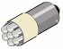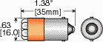Custom Optional Viewing Angles (1) see table
12º to 15º
Narrow Angle (N)
595nm Super Yellow
B606-0UY-014N $18.00 each
https://www.netdisty.net/ds/B606/default.asp
Brake Lights: (these may be too large?)

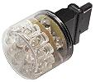
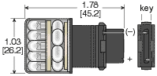
AUT3156-0ER-014V
$48.50ea
Other Voltages†: 24V, 28V, 36V, 48V 633nm
Replacement for: Incandescent #3156, 3156K, 3456
Wedge Base Size: 0.625 in.
Forward Current (max):
(Red, Yellow) 160mA
(White) 120mA
Total Light Output:
Red (End Lumens / End Footcandles): 100 Yellow (End Lumens/End Footcandles): 72 Cool White (End Lumens/End Footcandles): 124 Number of LEDs: 24

Turn Signal:
for 12/14 Volt Applications
AUT3156-0UY-014V
$48.50ea Other Voltages†: 24V, 28V, 36V, 48V
YELLOW
595nm Back-Up Light
for 12/14 Volt Applications
AUT3156-0CW-014V
$84.00ea Other Voltages†: 24V, 28V, 36V, 48V WHITE
8000K
https://www.netdisty.net/ds/aut3157/default.asp

License Plate Lights:
Instrument / Dashboard / Cabin Interior LED Replacement Lights
T3¼ (9mm) Miniature Wedge Based Bulb
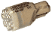 | 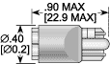 | For bulbs where light is directed at  right angles to the base, click here
Series WF3126 Replaces Incandescents: 124, 158, 161, 168, 194, 658
LED Color Base Size Electrical-Optical Characteristics T_{a} = 25°C) No. of LEDs Ι_{f}
WF3126-0CW-014B $24.00 10 White 9mm 15 900 12/14 8000K* 6

https://www.netdisty.net/ds/AUT67/default.asp#9mmwedge

