Tufts University Electrical Engineering Department



Nerd Girls Project Final Report
2003-2004

Laurel Hesch
Emily Mower
Sharon Smith

May 10, 2004

Horn Circuit:

The car horn will function to warn other cars or pedestrians of its presence. The horn generates a loud noise (at 125 dB) when the push button is pressed. The actual horn volume (not perceived volume) remains at a constant frequency for all voltage. In order to output a noise, a minimum of 5 to 13 Amps is needed. Adjusting the voltage levels directly alters the audible volume of the horn noise. A voltage source of approximately twelve Volts produces a softer sound, while a voltage source of approximately ten Volts produces a louder sound.
The working circuit consists of: a horn piece, push button, 10-Amp Fuse and a voltage source. The horn piece is connected in series directly to a push button. The Horn Push Button is a driver-friendly button installed on the side of the steering wheel, with a flexible semi-circular Aluminum piece of metal that expands when pushed. The push button is connected in series to a 10-Amp Fuse to the car from a power overload. The fuse contains a narrow strip of metal, which is designed to melt (safely) when the current exceeds the rated value, thereby interrupting the power to the circuit.
The fuse is then connected directly to the voltage source (figure 5).

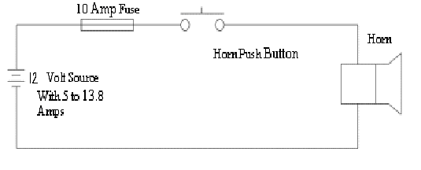
Figure 5: Horn Circuit Diagram

For further information regarding the parts used, refer to the following table:

Bill of Materials Table:

Item: | Quantity: | Cost:
Horn Bocina Avertissuer | 1 | $13
Universal Horn Button | 1 | $5
Mini 10 Amp Fuse | 1 | $3
Primary Wire- 14 Gauge | 1 | $4

Commentary:
The car horn was quite simple to build, however there were a few minor problems encountered. Initially, when setting up the circuit, the power supply located in the laboratory was used and the car horn only vibrated when the button was pushed. There was no audible sound. After consulting with the group, it was thought that the sound was inaudible because the horn piece purchased did not contain a cone, and thus could not “resonate” the vibrations into an audible sound. This was not the case. After buying, a horn piece with a cone shape, the horn still did not output a sound. After consulting with Mr. Warren Gragosian, it was determined that the power supply in the laboratory was not a sufficient power supply to produce the current needed to power the horn. The laboratory power supplies could only generate ~0.5 Amps, while the horn needed a minimum of about five Amps to function properly. Once, the correct Regulated DC power supply (built by RSR Electronics, model 3010) was found, the horn produced a very loud noise, as expected.
In addition to this minor setback, the group also encountered a problem with the horn push button. The first push button purchased, turned out to be too small and difficult to push. To overcome this, a large, very driver friendly horn push button was found at Radio Shack. This accomplished the task. The horn push button was modified for use, the metal leads were attached to the screws and the metal frame was bent a little to make it functional for the solar car. All parts were then combined for a functional and loud solar car horn.

RPM Detection System:

To begin, rpm stands for revolutions per minute; and according to web definitions it is “the speed of rotation of the crankshaft in an engine or other rotation shaft.” The main purpose of the rpm system is to calculate and display the instaneous speed of the car for the driver. The rpm system displays speeds in miles per hour and only outputs speeds above five per hour.
The first aspect of this system begins with the car wheel. On both front car wheels, two sets of four circular ceramic magnets will be placed on the inside spokes of the wheel. As listed in the bill of materials below, ceramic magnets (Radio Shack, item #64-1888) were used. The magnets were placed on the inside of the wheel as suggested by the Mechanical group to avoid external disturbances (ie. bad weather). Each magnet set consists of four strong magnets. The next component of this system is the digital Hall-effect sensor. According to the allegro.com FAQ, a digital hall-effect sensor is “Digital switches simply turn on or off with the presence or absence of a magnet, vs. a linear output Hall-effect sensor, whose output changes in proportion to the magnetic field present.” For more information about the digital hall-effect sensor refer to www.allegromicro.com. The digital Hall-effect sensor is able to function in a magnetic field with only two magnets, however in order to best perform; four magnets are needed in the design. Four magnets provide a stronger magnetic field for the sensor to detect the signal more accurately. The digital sensor will be placed near the magnets on the stationary car frame. Since the frame has not yet been built, it has not yet been decided precisely where the digital sensor will be located. This will be determined, once the car is built. It is suggested that the sensor be glued onto a metal bracket (can be bought at any hardware store) and then the bracket be attached to the sensor to the car. A bracket is “a wooden or metal mounting device designed to fit in the pinhole of an insulator, and attach it to a (normally) vertical surface such as a pole or the side of a building.” The metal bracket (where the sensor is attached to) must be within 5/16 of an inch from the magnets for full functionality. If the sensor is any further away than 5/16 of an inch then the digital sensor will not detect the magnetic field and hence no readings will be made and the speed will not be determined. Each time a North Pole of the magnet passes the Hall-Effect sensor is triggered.
The sensor was chosen because it is the most accessible and can easily be mounted to the car body. Additionally, the sensor is durable and performs within a wide range of temperatures. Refer to the specification sheet for more information regarding the digital Hall-Effect sensor. The Hall-Effect sensor requires a power source of five Volts. The sensor is active low, which indicates that it generates a 4.8 Volt signal until the magnet passes. When the magnet passes the sensor, the sensor produces a zero Volt signal. A pull-up resistor of approximately 10K was connected from the voltage source across to the signal output. The pull-up resistor can be anywhere between 2.2K to 0K, however the sensor performs maximally at 10K (figure 6). The key function of pull-up resistor is to “prevent input lines from floating…and the resistor itself functions to prevent too much current from flowing through the pull-up circuit.”
Refer to diagram 6 and diagram 7 for more details about the Digital Hall-Effect block diagram
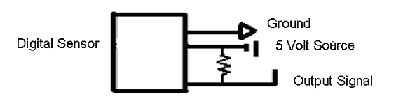

Figure 6: Digital Hall-Effects Sensor

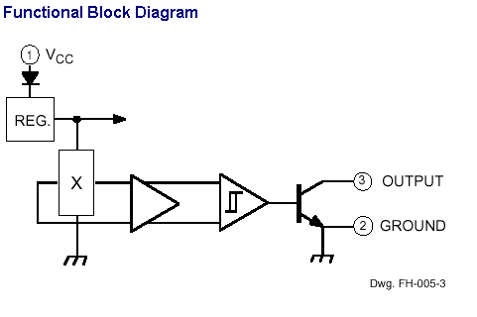

Figure 7: Functional Block Diagram of Digital Hall-Effect Sensor

Once the Hall-effect sensor senses the shaft pulse, the pulse is sent directly to OOPic microcontroller. The OOPic is then programmed to input the value on pin 2 and convert it into an object. (See Source Code for further reference) The oA2D is a hardware object that takes an analog voltage presented to one of the OOPic's I/O lines and converts it to a digital value. This is very similar to an A2D counter. Next, the main program initializes an oByte called ClockCounter. The oByte ClockCounter is contained in a separate subroutine, where it (independent from the main program) increments the clock every second. To accomplish this, an oClock object labeled tick is used. The oClock object utilizes the following formula in order to determine the frequency of the clock, Frequency = 283/ (256 - Rate), where the rate is left up to the programmer. It was found that the rate was not accurate and hence, after a trial and error process, it was determined that a rate equal to 90, generates a clock pulse every second. A second subroutine is defined as ClockInterrupt_Code. In this subroutine, the oByte object named InputCounter is defined. Te object, InputCounter is incremented each time a pulse is detected. In order to detect the pulse, an oEvent object is defined as ClockInterrupt. This object links the ClockIntterupt subroutine to the main program. In the main program, an oByte object B is set equal to the ClockCounter object. When B is equal to five seconds the revolutions per minute are calculated. The number of pulses is multiplied by twelve so that the value displayed on the LCD (liquid crystal display) is in revolutions per minute. Every five seconds a new value is displayed on the LCD (figure 7). Refer to the following flow table for details on how this entire system works:

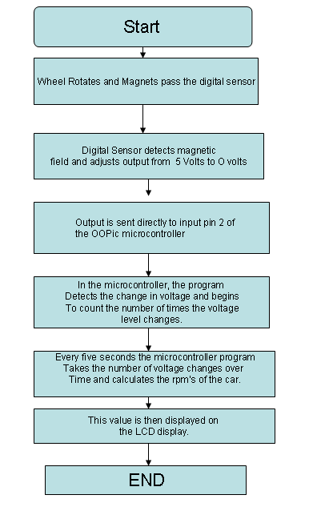

Figure 7: RPM Flow Diagram

Commentary:
Overall, the design of this system seems quite simple, however when actually building it, several problems were encountered. Firstly, the digital sensor that the group first purchased were too small and hence, new digital sensor had to be ordered.
This was a minor problem, but it is very important for the future groups to be aware that if a vendor says a part is a SSI or MSI, then it is too small for proper use. (Beware of SSI and MSI)! The second problem encountered was a problem pertaining to the interface between the OOPic microcontroller and the digital sensor output. For some reason, the OOPic was not able to read the input (coming from the sensor). Several test trials were completed to find out what type of variable declaration is needed in order for the OOPic to recognize the change. It was found that the object name, oA2D was needed in order to recognize the sensor outputs. Once this was determined, there were no further problems encountered with the system, however there are a few adjustments that can be made for the future teams working on this project. Firstly, it might be useful to use a faster processor. The future group may want to look into processor speeds and compare them with the OOPic’s. The speed of the OOPic is suitable for most of the Nerd Girl’s purposes, but may not be the best fit for all purposes.
In addition to this, it is useful for next year’s group to know that sometimes problems are encountered with running the OOPic. If it does not turn on one should verify that the OOPic is getting ample power. The OOPic has a 2-pin power connector, ground and voltage, that must have at least six Volts to function properly. The green power on light will come on when the OOPic gets this six Volts. If the OOPic is powered on but for some reason this program is not working as it should, then remove the EEPROM (located next to the LEDs) from the board. This often will correct for any problems or errors that occur. This is my best advice for any problems that may be experienced.

Appendix 1: Bill of Materials

Item | Quantity | Cost
OOpic-R board | 3 | $79.00
Maxim Max 208 transceiver | 1 | $7.55
Xantrex Link 10 e-meter | 2 | $304.69
Scott Edwards  4x40 Serial LCD Display  Part Number BPP-440L | 1 | $159.00
LCD Display | 1 | $50
Brushless Motor (HCMC-48 VDC/100A) | 1 | not purchased by group
Generator Controller | 1 | not purchased by group
Hall-Effect Sensors | 3 | $20
Horn Bocina Avertissuer | 1 | $13
Universal Horn Button | 1 | $5
Mini 10 Amp Fuse | 1 | $3
Double Pull Double Throw Switch | 1 | Electrical Engineering Dpt. ($0)
Double Pull Single Throw Switch | 1 | Electrical Engineering Dpt. ($0)
Breadboard for prototyping | 1 | $10.97
Breadboard for prototyping | 2 | Electrical Engineering Dpt. ($0)
555 Timer | 1 | Electrical Engineering Dpt. ($0)
SN74LS153 4:1 Multiplexer | 1 | $0.45
Magnets | 8 (2-packs) | $5
Digital Potentiometer | 2 | $2.22
10K-Ω Resistor | 1 | Electrical Engineering Dpt. ($0)
11K-Ω Resistor | 1 | Electrical Engineering Dpt. ($0)
15K-Ω Resistor | 1 | Electrical Engineering Dpt. ($0)
.47 μF Capacitor | 1 | Electrical Engineering Dpt. ($0)
1mF Capacitors | 5 | $0.37
Primary Wire- 14 Gauge | 1 | $4
Appendix 4: Source Code for RPM Detection

'Sharon Smith
'This program reads the analog value from I/O line 2.
'From this value it calculates the number of revolutions per minute 'and outputs it on an LCD display.
Dim Input As New oA2D
Dim Output As New oDio8
Dim Red As New oDio1
'Dim InputCounter As New odio8
Dim InputCounter As New oByte
Dim A As New oByte
Dim B As New oByte
Dim Tick As New oClock
Dim ClockInterrupt As New OEvent
Dim Green As New oDio1
Dim ClockCounter As New oByte
Dim flag as new oByte
Dim RPM as new oWord
Dim Previous as new oByte
dim lcd as new olcdse
Sub Main()
'------Magnet Trigger Initialization---------------------------
InputCounter = 0
A =0
B= 0
Red.IOLine=7
Red.direction=cvoutput
Output.IOGroup = 1
Output.Direction = cvOutput
Input.ioline = 1
Input.operate = 1
'---------Clock Initialization----------------------------------
ClockCounter = 0
Tick.Rate = 90 'Frequency = 283/ (256 - Rate)
Tick.Mode = 1
Green.IOLINE = 5
Green.Direction = cvOutput
Tick.Output.Link(ClockInterrupt.Operate)
'-----------Start Interrupts---------------------------------
Tick.Operate = cvTrue
Do while B < 6
Output.Value = Input.Value
if Input.Value = 0 then
Red= cvon
InputCounter = 1
elseif input.value = 1 then
Red= cvon
InputCounter = 1
Else
Red = cvoff
InputCounter=0
End if
If InputCounter = 1 then
if not Previous and InputCounter then
A=A+1
end if
End If
B =ClockCounter
if B=5 then
RPM=A*12
A=0
ClockCounter=0
B=6
end if
Previous=InputCounter
loop
'----------------Output value onto lcd-------------
dim hundreds as new oByte
dim tens as new oByte
dim ones as new oByte
hundreds= ((RPM/100) mod 10) +48
lcd.value=hundreds
oopic.delay=10
tens= ((RPM/10) Mod 10) +48
lcd.value=tens
oopic.delay=10
ones= (RPM Mod 10) +48
lcd.value=ones
oopic.delay=10
oopic.delay=100
lcd.clear
end sub
Sub ClockInterrupt_Code()
Green.Invert
ClockCounter = ClockCounter + 1
End Sub

