BRUSHLESS MOTOR CONTROLLER
(with regenerative braking)
Models BRLS100H, BRLS150, BRLS250, BRLS240H
--------------------------------------------------------------------------------------------------------------------------------------------
Caution!
Follow these instructions carefully. Improper set-up may damage equipment or injure user.
THE UNIT IS NOT WATER SEALED-PLACE IN A WATER TIGHT CLIMATE!
--------------------------------------------------------------------------------------------------------------------------------------------

THE UNIT
The Solectria brushless motor controller is specifically designed to control the speed and torque of a brushless permanent magnet motor. This brushless motor controller is a variable frequency, current controlled, current limited control system. It is based on a super low-resistance MOSFET switched at up to 20kHz. This controller requires an inductive load which must be within a prescribed range or the MOSFET devices could be damaged. A very low or high motor inductance must be accounted for in the values of the power stage and circuit board elements which are installed at the factory.

Depending on the model, the controller can control up to 100A, 150A, 200A, or 240A of motor current in drive or regenerative braking mode. The basic control topology is that of a down converter. If the motor is running at half speed, its peak voltage per phase will be half that of the battery and the peak motor current per phase will be double that of the battery. At full speed, the peak voltages and peak currents will be similar

ADJUSTMENT
Current limits are factory preset. These should not be changed for any reason or the motor or controller will be damaged.

MOUNTING
It is best to mount the controller on rubber pads to reduce vibration. The heat sink must be kept in an open ventilated area. A brushless muffin fan uses very low power, and will help assure that the device stays cool. The controller is not totally waterproof and should be inside the car out of weather. If it gets wet, it should NOT be operated until it has thoroughly dried out.

NOTES ABOUT USE
The unit is fairly robust but do not drop it or allow anything to drop on the controller. Do not allow direct sunlight to shine on the circuit board and do not open the case. HAPPY MOTORING.

MOTOR CONTROLLER FACE PLATE

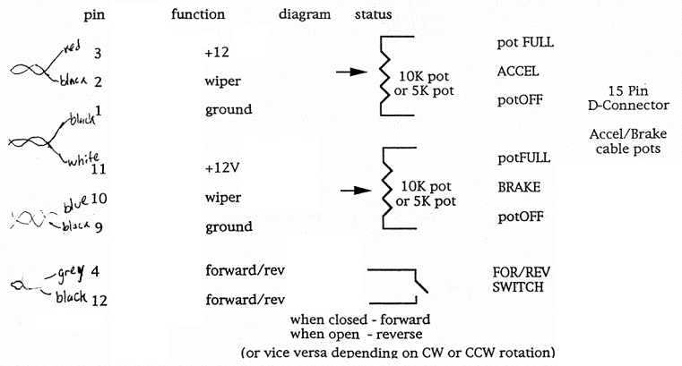
Solectria
27 Jason Street
Arlington, MA 02174
(508) 658-2231
fax: (508) 658-3224

SET-UP
MOTOR CONTROLLER FACE PLATE
Accel/Brake Connection
To connect the accelerator and brake-controls to the Motor Controller, you will need:

1. two (2) 10K Ohm potentiometers (or 2 of Solectria's 5K Ohm accelerator/brake controller, model ABC1)
2: one (1) 15 pin male D connector
3. one (1) double-pole, single throw switch

Please use good quality potentiometers and be sure that the connecting work, soldering etc. is done by a skilled person. The motor controller is designed with some protection for bad pot connections, but shorting certain pins could damage the controller. Wrong or faulty potentiometer connections can be very hazardous - Remember, you are dealing with automobiles, boats and other powerful potentially dangerous machines.

Potentiometer (Pot.)
Close Up of 15-pin female D Connector (found on the controller box)
Close Up of soldering side of
15-pin male D connector
(This connector plugs into the
controller box female D connector)
To connect the potentiometer that controls acceleration:

1. Connect pin 1 of the pot. to pin 1 of the male D connector.
2. Connect pin 2 of the pot. to pin 2 of the male D connector.
3. Connect pin 3 of the pot to pin 3 of the male D connector.

To connect the potentiometer that controls regenerative braking:

1. Connect pin 1 of the pot to pin 9 of the male D connector.
2. Connect pin 2 of the pot to pin 10 of the male D connector.
3. Connect pin 3 of the pot. to pin 11 of the male D connector.

Solectria
27 Jason Street
Arlington, MA 02174
(508) 658-2231
fax: (508) 658-3224

To connect the forward/reverse switch:

1. Connect one side of the switch to pin 4 of the male D connector.
2. Connect the other side of the switch to pin 12 of the male D connector.

Pins 5-8 and 13-15 are not used. The male 15 pin D connector is plugged into the D connector on the controller.

Motor Feedback Connection

This connection uses a 9 pin D connector. Simply plug the 9 pin D connector from your Solectria motor into the D connector mate on the motor controller.

If your are not using a Solectria motor, please call us about the correct adaptation to the motor feedback port. A special converter may be required to change the feedback logic.

Motor Phase Connection

The controller has three leads for connecting to your brushless permanent magnet motor phases. These leads are labeled Phases A (red), B (white), and C (blue or black) and correspond to the leads from your Solectria motor. Some controllers are manufactured with all three leads white. In this case, look for A, B, C markings at the end of the wires or on the case. Connecting to this correctly will enable your motor to .. operate properly, firing the motor's phases sequentially.

If you are not using a Solectria motor, you will need to determine the sequence in which your motor phases fire in order to connect to the motor controller. Please use heavy duty connectors to connect to your motor from these phase leads, making sure to insulate the wires from one another. If the motor runs very roughly or not at all after connecting it, you probably haven't hooked it up correctly and need to switch two wires.
We have 3-pin connectors for motor leads available.

Battery Connection

The last connection is to the battery cables. Polarity must be observed: red or white (+) to battery+, black (-) to battery -. Before connecting the battery to the power cables on the motor controller, be SURE that the MOTOR CABLES are safely insulated from each other and any outside object! Please use a high current fuse on the positive power lead in series with the positive terminal of the batteries and the positive lead on the controller - depending on the controller, a 160 Amp to 250 Amp fuse is recommended. Careful connection to the battery terminals is critical for the safe and proper operation of your controller.

When operating the controller, be sure to have your motor carefully restrained to allow for safe operation of both motor and controller.

Power Connectors: We recommend that a connector with suitable current carrying capability be employed for the battery connections and if possible the motor connections as well. We have available a quality, lightweight, silver plated two conductor connector in two sizes - 50A continuous $16.50 for set of 2 , or 175 A continuous $19.80 for set of two.

