Solar Panel
820 BP Solar Mono-Crystalline Solar Cells
17% Mfgr. Cell Efficiency (Third Party Tested at 15%)
12% Panel Efficiency
1000 Watt Peak Power with voltage range of 100 (with MPPT) or 205 volts (MPPT bypassed)
4 Student Designed & Built Maximum Power Point Trackers (microprocessor controlled)
Average Power (direct Sunlight) 900W
Maximum Observed Power (MPPT bypass) 1360W
66 kph (41 mph) on 1000 W of Panel Power

Batteries
12 U1 DieHard Batteries in Series for 144V Bus - 4900 Kwh
33 Ahr with a total weight of 113.4 kg (250 lb) 165 mile average daily range (Designed)

Motor
Solectria 8 kW (11 HP) Brushless DC 3 phase
94% Efficient at 6000 RPM with Solectria BRLS240H MOSFET Controller
Maximum Speed Estmated at 105 km/h (65 MPH) Blower Cooling

Wheels\Tires
50 cm (20") RL-Edge Racing Tires, 100 PSI
Student Designed & Built Machined Billet Aluminum Wheels

Weight
352 kg (775 lb) without driver
Driver : 80 kg (176 lb)

Dimensions
Length: 6 m (19.69 ft) Width: 2 m (6.6 ft) Height: 1.1 m (3.61 ft) Clearance: 0.30 m (.98 ft) Wheelbase: 2.5 m (8.2 ft) Track Width: Front - 1.5 m (4.9 ft) Rear - 1.6 m (5.25 ft)

Brakes, Suspension & Steering
3 Wheel disc with regenerative braking
Double Wish Bone Front Suspension and Independent Trailing Arm Rear
Chain to Rack & Pinion Steering
Risse Racing Tech gas shocks
Suzuki ATV Hydraulic disk front & back brakes + Regen on Left Rear
Single Reduction Chain, 7/1 ratio

Chassis
Thin-wall 4130 Cr-Mo steel tubing with rear Kevlar & Foam monocoque body

Aerodynamic Specs
Drag Coefficient, Cd = 0.17 (EDS computer simulation)
Frontal Area, A = 1.0 m²

Accomplishments
Sunrayce 93 - Dallas to Minneapolis, 8th Place
Sunrayce 93 - Teamwork Award, 1st Place
Sunrayce 93 - SAE Engineering Excellence Award
American Tour de Sol 95 - 1st Place Solar Cross Continental Category
American Tour de Sol 95 - Most Efficient Solar Cross Continental Category
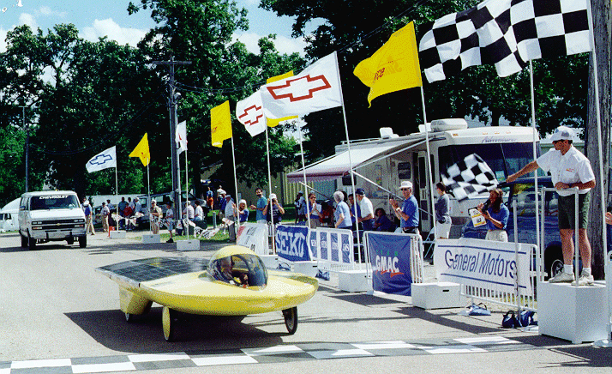

Team Members
1993
Paul Batcheller - did MPPT for MS Thesis
Chris Beard
John Beaudoin
Batu Berkok
Pat Borzi
Chris Cooper
Bill Lynch
John Kenny
M.Subhan Khan
James Nelson - Team Captain
Mike Reinhardt
Adam Rux
Guy Sliker
Walter Vericker
Advisors - Dr.John Duffy & Alan Rux
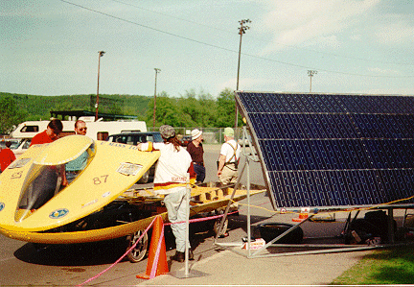Tour de Sol '95
1995 American Tour de Sol Team
John Beaudoin - Mechanical, Team Leader, Driver
Steve Garrison - Electrical, Mechanical, Team Leader, Driver
Jeff Tarquinio - Electrical, Driver
Advisor - Alan Rux

